* This is the assignment to be completed by Friday April 25.
* You can do the problems in the student journal or on blank paper. Send a photo of the completed work to the google classroom. If you don’t know how post to google classroom contact your teacher.
* I will post fully worked out solutions to certain problems at the beginning of next week so you can see how to solve each of the problems listed below. If you get stuck, look at these examples. I will provide full solutions at the end of next week so you can check your work.
* I have attached the rules for most of the transformation in this chapter at the bottom of this document.

**Assignment – Part 1**

Use the Student Journal, the vocabulary flash card file in the Google Classroom or by searching the internet to find and write the definitions to the vocabulary words on pages: 99, 104, 109, 114, 119 and 124. Try to memorize these definitions.

**Assignment – Part 2**

|  |  |  |
| --- | --- | --- |
| Reference these Page(s) | Problem Page | Problem Numbers |
| 100 | 100-101 | 1, 3, 5, 8, 10 |
| 104-105 | 105-106 | 2, 5 |
| 109-110 | 110 | 1, 2, 3, 4, 5 |
| 114 | 115-116 | 1, 4 |
| 119-120 | 120 | 1, 2, 3 |

**Most of the Rules Needed For This Chapter**

Translations

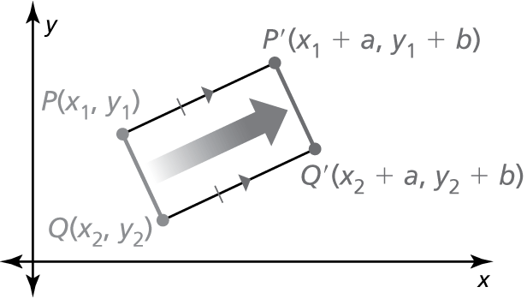A **translation** moves every point of a figure the same distance in  
the same direction. More specifically, a translation *maps*, or moves,  
the points *P* and *Q* of a plane figure along a vector to the   
points ** so that one of the following statements is true.

Coordinate Rules for Reflections

* If is reflected in the *x*-axis, then its image is the point 
* If is reflected in the *y*-axis, then its image is the point 
* If is reflected in the line  then its image is the point 
* If is reflected in the line  then its image is the point 

Coordinate Rules for Rotations about the Origin

When a point is rotated counterclockwise about the origin, the following are true.

* 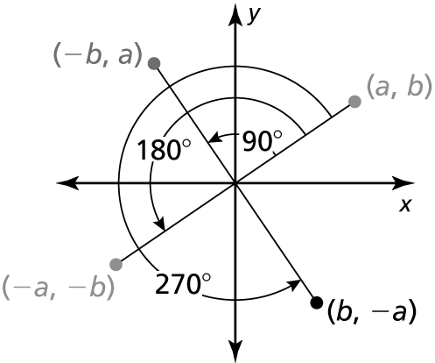For a rotation of 
* For a rotation of 
* For a rotation of 

Coordinate Rule for Dilations

Dilation with center at the origin.

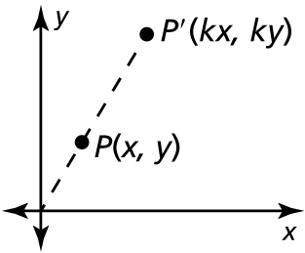If is the preimage of a point, then its image after  
a dilation centered at *C* with scale factor *k* is shown below.

**Center** **Image**

 

  