Industrial Revolution Investigation
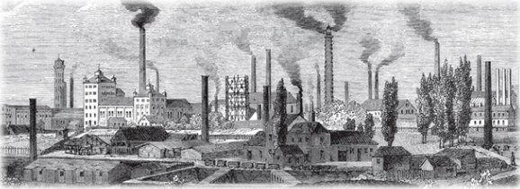
Directions: Use the website provided on Google Classroom to investigate important effects of the Industrial Revolution. Use the website to answer the following questions in complete sentences.
- Where did the Industrial Revolution originally begin? To which continent did the Industrial Revolution spread?

- How did societies in Europe and America change during the Industrial Revolution?

- How were products made before the Industrial Revolution? What was it called?

- What does “factory system” mean?

- Which industry was especially transformed by industrialization? What did this industry produce?

- What was a spinning jenny? Who was its inventor?

- What was the cotton gin? Who was its inventor?

- What is capitalism? How does capitalism differ from mercantilism?

- Identify at least 3 positive impacts from the industrial Revolution.

- Identify at least 3 negative impacts from the Industrial Revolution.

- The second to last paragraph states, “…the United States had become the leading industrial nation in the world.” Why do you believe the United States was able to take the lead in industrial growth?

- BONUS QUESTION: Summarize the graphic organizer titled “Overview of the Industrial Revolution” in your own words.

- BONUS-BONUS QUESTION: Identify the major event that initiated (caused) the Industrial Revolution in the United States. (Hint: We have talked about it before, but use google to investigate).

