Circulatory System
EXPLORE
Complete the activities in this order. | Answer the questions in a different color font.
Watch  Watch the… video by clicking the link below.  https://www.youtube.com/watch?v=-s5iCoCaofc  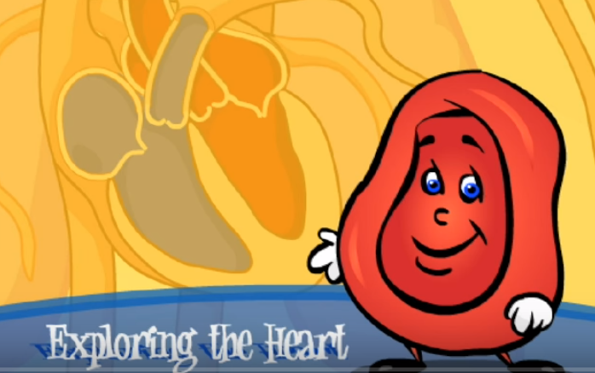 | Which system is important to blood cells?  In a city, what would a blood cell represent?  In a city, what would blood vessels represent?  What are the two types of blood vessels?  What do arteries carry?  What do veins carry?  What makes your blood move?  Where does blood go first after it leaves the heart?  What does it pick up to deliver to the rest of the body?  After he drops off all of the first gas, what gas does he gather to take to exit the body?
Read  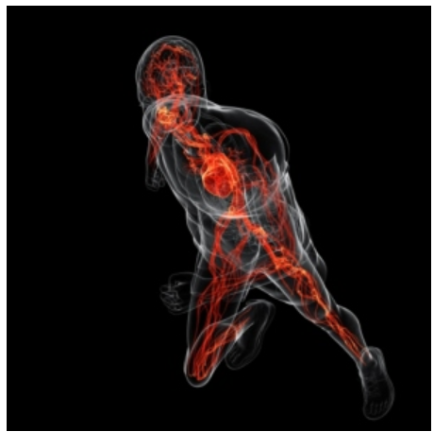  Read the … https://kidshealth.org/en/kids/heart.html | What is the main organ of the circulatory system?  How many valves are inside the heart?  What are the two types of blood vessel in the circulatory system?  Which blood vessel carries blood away from the heart?  Which blood vessel carries blood towards the heart?
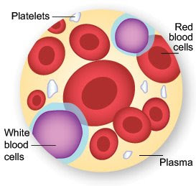  View The Drop of Blood and read the article.  https://kidshealth.org/en/kids/blood.html | Name and define the four parts of blood.  1.  2.  3.  4.
EXPLAIN
Watch this video https://www.youtube.com/watch?v=_eVG45_iF9U | How does oxygen get into the blood?  How does blood get pumped throughout the whole body?  What are capillaries?  What is the function of the circulatory system?
What did you learn about that you did not already know?
What type of blood cell in the body helps to fight infections?

