Biotic & Abiotic Factors Digital Interactive Activity
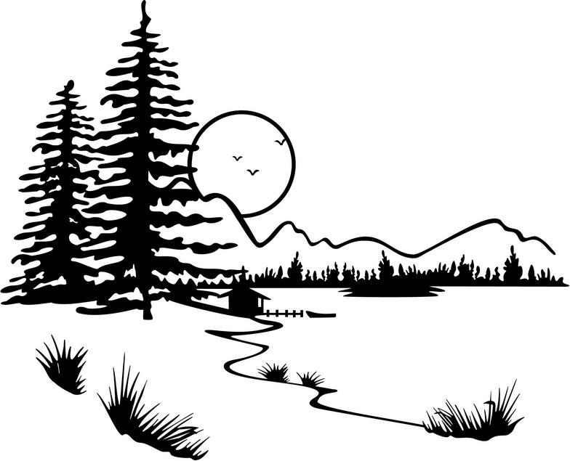

Directions: Click on each activity link in order, and then respond to each question within that activity.

Activity | Response
Explore | Explore this website about abiotic & biotic factors. Write five pieces of information that you found most interesting and explain why. Complete Data Table.  Information Explanation  1.  2.  3.  4.  5.  How can changing abiotic and biotic factors in an ecosystem cause it to change? Type Answer Here:
Examine | Examine these photos of ecosystems that contain abiotic and biotic factors interacting. Type your answer following each question:  - What was one ecosystem you were already familiar with?  - List three biotic factors from one of the photos.  A.  B.  C.  - List two abiotic factors from one of the photos.  A.  B.  4. Choose one of the pictures and explain how the non-living and living factors  depended on one another. Type your response here:
Watch | Watch this video on abiotic & biotic factors. Summarize what you learned from the video on abiotic and biotic factors below in 2-3 sentences:  Which example from the video did you like best? Why? Write your response here:
Learn | Learn about abiotic and biotic factors! Then, type your answer following each question:  - How do plants help ecosystems?  - How do animals help ecosystems?  - Why is rain important in an ecosystem?  - What would happen to an ecosystem if biotic and abiotic factors did not work together?
Compare | Compare and contrast abiotic and biotic factors! Then, complete the table.  Example: Biotic or Abiotic?  - water  - flower  - bunny  - sunlight  - temperature  - bacteria  How are the biotic factors of these two ecosystems different? Type Answer here:
Read | Read this article about how Antarctic animals are in danger of losing a major food source- krill (a biotic factor) Write a summary paragraph of the cause and effects of this problem. Type Paragraph Here:
Infer | Read this information about biotic and abiotic factors in an aquarium. Then, type your answer following each question:  - If there is no water can anything grow or survive? Why?  - Why was algae added to the aquarium?  - Why do you think it is called “duckweed”?
Analyze | Analyze this picture of a pond ecosystem. Then type your answer following each question.  - How does the fish depend on the abiotic factors to survive?  - How does sunlight, an abiotic factor, help the plants (biotic factors)?

Kristen Keegan, IUSD

