Government Responsibilities
The United States was built on democratic principles that promised to protect life, liberty, and the pursuit of happiness. Since then, there has been a constant debate about how to balance government involvement with individual freedoms. Before you explore the benefits and costs of the New Deal, consider the responsibilities of government and the extent to which it should take care of its people.
Read the following 2 articles after you have both articles come up with 3 questions that government programs should address.

1.

2.

3.

Article # 1

Opinion: Democrats run from socialism but embrace socialist policies
When Alexandria Ocasio-Cortez's primary victory was announced last Tuesday, much of the political left celebrated with glee. The former bartender not only beat incumbent Joseph Crowley in the race for New York's 14th Congressional District seat by a 15-point margin, she also ran as a socialist and spoke of the Democratic Party as a "big tent" with room for the far left.
But by Wednesday afternoon, some of the air had been let out of the balloon. House Minority Leader Nancy Pelosi, Democrat from California, brushed off the suggestion that Ocasio-Cortez's win means much of anything, saying that a win in one district "is not to be viewed as something that stands for everything else." Her dismissiveness highlighted the continued tension between socialists and Democrats, a relationship that has long been defined by feigned distance and symbiosis.
While Republicans have relied on socialism as a bogeyman over which to feign horror, Democrats have grappled with a desire to be seen as far from socialists on policy while adopting causes and initiatives for which socialists have called. It's a dynamic that has kept socialists at the margins of American politics, even as their policies have become mainstream.
The history of socialism in the United States is fraught and chaotic, its popularity shifting with the economic and political landscape. Proto-socialists in the early 1800s called for the abolition of slavery and established short-lived Utopian communities. With the influx of German immigrants in the mid-1800s came Marxism, the founding of communist and socialist parties, and alliances with the labor rights movement. Despite infighting and schisms over unionism and political action, socialism was on a limited ascent as the 19th century came to an end.
In 1901, Eugene Debs co-founded the Socialist Party of America. Although never a party of more than 100,000 members, the Socialist Party was able to elect numerous candidates to local office in states from coast to coast, and Debs received more than 900,000 votes during his presidential runs in 1912 and 1920. Despite their electoral wins, socialists remained on the fringes of power.
The parties, however, did not just allow socialists to linger on the fringes. The first Red Scare, in 1919 and 1920, was less effective than Senator Joseph McCarthy's, but it had a similar goal. In response to labor uprisings, the Russian Revolution and bombings by anarchist groups, Attorney General A. Mitchell Palmer began a campaign of propaganda and targeted raids against groups on the far left. Although the campaign ended in 1920, it set socialism up as an enemy of the state in ways that have lingered. Socialism was associated with Russian Bolshevism and characterized as a dangerous foreign force that stood against democracy. Democrats and Republicans took up the anti-socialist cause in equal measure; when the New York State Assembly moved to expel five socialist members, only one Democrat opposed the action.
But the passage of New Deal legislation revolutionized the relationship between the state and the citizen, introducing the broad notion that the government has a responsibility to ensure the welfare of its people. In a 1934 article for the Atlantic, Harold Laski noted that President Franklin D. Roosevelt's policies were aimed at ensuring capitalism was "the servant, and not the master, of the American people" by ensuring some level of social welfare for the public. While not crimson, this was certainly a shade redder than American policy in the past.
Under Roosevelt, the modern dynamic between the mainstream parties and socialism was crystallized: The Democrats would borrow from socialist policy proposals while disavowing the ideology in attempts to weather rhetorical attacks from Republicans. When he was slammed as a socialist by Republican politicians, Roosevelt defended himself by denying the association, rather than defending the merits of socialist ideas. When President Harry S. Truman was accused of being a socialist, he responded by diminishing "socialist" to a throwaway pejorative, saying in 1950: "Confronted by the great record of this country, and the tremendous promise of its future, all they can croak is 'Socialism!' "
Socialism became truly toxic in the mid-20th century, building on the decades that came before. McCarthy's decade-long harassment of those he accused of being socialists or communists began in 1947. For the rest of the century, "socialist" was one of the dirtiest words in politics, helped along by Cold Warriors such as President Ronald Reagan. The rise of the counterculture in the 1960s and 1970s didn't provide a foothold for socialists like the upheaval of the late 1800s and early 1900s had; Bernie Sanders is the only socialist activist to emerge from that period with influence.
While antagonism between the Republican Party and socialists remained fervent throughout the 20th century, the relationship was more complex between socialists and Democrats, even though shades of red can be seen in party policies aimed at combating housing discrimination, making college more affordable and increasing access to health care. Even as Democrats borrow from socialists, be it on building the social safety net in the 1960s or calling for the abolition of Immigration and Customs Enforcement today, they insist on differentiating themselves.
President Lyndon B. Johnson was dismissive of accusations that he was promoting socialism, telling Barry Goldwater in 1960, "I think all of us have to decide for ourselves what represents a 'socialist' platform." His landmark Great Society legislative program and War on Poverty included civil rights legislation and Medicare, which Reagan warned would bring about socialism in the United States. President Jimmy Carter, while further to the right than many in his own party at the time, introduced a failed proposal to provide basic health care for all Americans. The Clintons' efforts to pass health-care legislation in the post-Reagan 1990s were met with cries of socialism from the right, to which President Bill Clinton responded much as Roosevelt had, defending his initiatives by highlighting the place of private insurance while denying any association with socialist ideas. In 1998, he went further, equating socialism with totalitarianism, saying that the 20th century saw "the victory of democracy over totalitarianism, of free enterprise over state socialism," in a speech honoring Roosevelt's legacy, including the New Deal.
Under President Barack Obama, the right's heavy use of socialism to decry government policies such as the Affordable Care Act became a running joke on the left. Still, Obama encouraged those who accused him of being socialist to "meet real socialists" and defended his policies by citing his capitalist credentials. Even in 2015, Hillary Clinton was dismissive of socialism, saying during a debate, "We are not Denmark," a reference to the democratic socialist systems many point to as examples for the United States.
In 2016, commentators frequently remarked that Sanders had pulled Clinton to the left during the campaign. Whether true or not, that sentiment captures the dynamic between the Democrats and socialists for over a century; socialists have long been the leftward flank of the political spectrum, offering ways forward but being kept from power. But this dynamic is increasingly untenable as income inequality continues to rise, the gig economy creates unsustainable working conditions and social-justice issues go unresolved. Consider that Clinton suggested that identifying as a capitalist (while qualifying that she wants accountability) became a liability among some potential Democratic voters during the campaign.
The question now is whether this flurry of interest in socialism will be sustained and whether Democrats, who have long been harried by red fright and responsible for enabling it, will make space for socialism. While the Republicans continue to decry socialism as a threat to the fabric of our society, the Democrats have a chance to capitalize on the momentum of young, up-and-coming leaders such as Ocasio-Cortez and welcome socialists into the fold for the first time.
Article #2

Conservatism in the United States
The perception of the United States as an inherently liberal country began to change in the wake of the New Deal, the economic relief program undertaken by the Democratic administration of President Franklin D. Roosevelt in 1933 to help raise the country out of the Great Depression. This program greatly expanded the federal government's involvement in the economy through the regulation of private enterprise, the levying of higher taxes on corporations and the wealthy and the expansion of social welfare programs. The Republican Party, drawing on the support of big business, the wealthy and prosperous farmers, stubbornly opposed the New Deal.
As Democratic liberals moved to the left in endorsing a larger role for government, Republicans generally clung to a 19th-century version of liberalism that called for the government to avoid interfering in the market. This policy produced little success for Republicans at the polls. In matters of foreign policy, however, the Old Right, as these staunch conservatives were known, was powerful and popular enough to prevent the United States from entering World War II until the Japanese attack on the U.S. naval base at Pearl Harbor, Hawaii, in 1941. By the time the Republicans regained the presidency in 1953, they had accepted most of the New Deal reforms and were preoccupied with the battle against communists at home and abroad.
In the first decades after the war, the United States, like Britain, gradually expanded social services and increased government regulation of the economy. In the 1970s, however, the postwar economic growth that the United States and other Western countries had relied on to finance social welfare programs began to slacken, just as Japan and other East Asian nations were finally attaining Western levels of prosperity. Whatever the causes of the West's economic stagnation, it became clear that liberal policies of governmental activism were incapable of solving the problem.
At this point, a new group of mainly American conservatives, the so-called neoconservatives, arose to argue that high levels of taxation and the government's intrusive regulation of private enterprise were hampering economic growth. No less troubling, in their view, was the way in which social welfare policies were leading those who received welfare benefits to become increasingly dependent upon government. The neoconservatives generally accepted a modest welfare state — indeed, they were sometimes described as disenchanted welfare liberals — but they insisted that social welfare programs should help people help themselves, not make them permanent wards of the state. In this and other respects, neoconservatives saw themselves as defenders of middle-class virtues such as thrift, hard work and self-restraint, all of which they took to be under attack in the cultural upheaval of the reputedly hedonistic 1960s. They also took a keen interest in foreign affairs, adopting an interventionist stance that set them apart from the isolationist tendencies of earlier conservatives. Many of them argued that the United States had both a right and a duty to intervene in the affairs of other nations in order to combat the influence of Soviet communism and to advance American interests; some even claimed that the United States had a duty to remake the non-Western world on the model of American democratic capitalism.
Among American political leaders, the chief representatives of neoconservatism were the Republican presidents Ronald Reagan (1981–89) and George W. Bush (2001–09). Its most articulate advocates, however, were academics who entered politics, such as New York Senator Daniel Patrick Moynihan and Jeane Kirkpatrick, who served as ambassador to the United Nations during the Reagan administration.

Legacy And Prospects
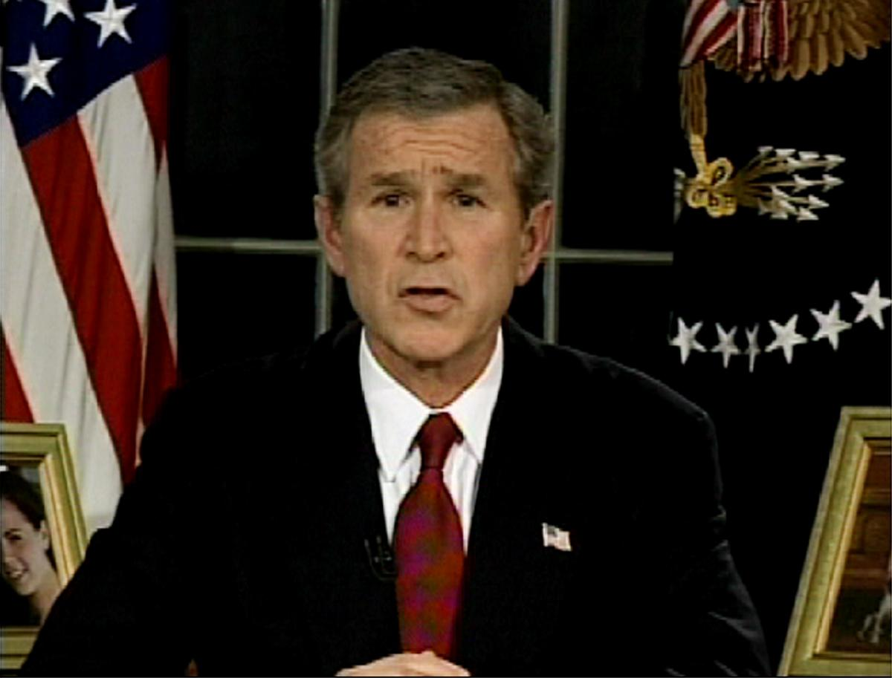
Division, not unity, marked conservatism around the world during the first decade of the 21st century — this despite the defeat of conservatism's chief nemesis of the previous 50 years, Soviet communism. But perhaps this fissure is not surprising. Anticommunism was the glue that held the conservative movement together, and without this common enemy the many differences between conservatives became all too painfully clear. In Europe, for example, conservatives split over issues such as the desirability of a united Europe, the advantages of a single European currency (the euro, introduced in the countries of the European Union in 2002), and the region's proper role in policing troubled areas such as the Balkans and the Middle East.
Image 2. President George W. Bush announces the U.S. invasion of Iraq on March 19, 2003, in the Oval Office of the White House in Washington, D.C. The war on terror marked his presidency. Photo from: AP/via APTN.
Conservatism was even more divided in the United States. Abortion, immigration, national sovereignty, "family values" and the "war on terror," both at home and abroad, were among the issues that rallied supporters but divided adherents into various camps, from neoconservatives and "paleoconservatives" (descendants of the Old Right, who regarded neoconservatives as socially liberal and imperialistic in foreign affairs) to cultural traditionalists among "religious right" groups such as the Christian Coalition and Focus on the Family. The camps battled one another as well as their perceived enemies in the so-called "culture wars" from the 1990s through the first decade of the 21st century. By the time of the congressional elections of 2006 and the presidential election of 2008, however, it was clear that such infighting had taken its toll. Two military invasions and occupations abroad, in Afghanistan and Iraq, had proved enormously expensive in American lives and treasure and cast doubt on the wisdom of the neoconservatives' call for a more interventionist U.S. foreign policy backed by military might. While American conservatives had long called for smaller government, balanced budgets and leaving education to the states, the policies of the putatively conservative George W. Bush administration contradicted those key tenets of conservatism. And the global economic crisis that began in 2007–08, during the final year of the Bush administration, turned Americans' attention away from cultural issues such as same-sex marriage and toward more material concerns. The "new New Deal" introduced by Democratic President Barack Obama's administration in 2009 angered and upset many conservatives, whose ranks nevertheless remain divided.

