Name: Date:

Function Notation Translations Notes

a f(x-h) +k

Describe the translation (movement) of each graph.
Ex) f(x-4) Ex.) f(x+3) Ex.) f(x)-4 Ex.) f(x-2)+3

Ex.) Graph the equation f(x)=2x+4 below. Then on the same graph, graph f(x+3) as a dotted line. Label at least 3 points.
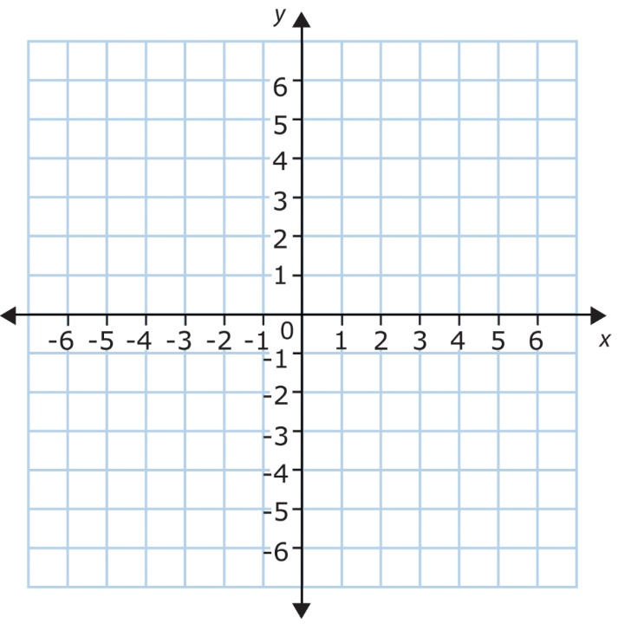

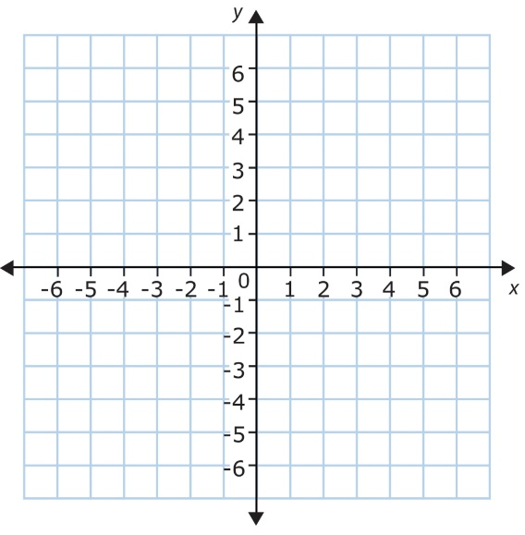
Ex.) If the shape on the graph below represents f(x) graph f(x+3)+6.

Ex) If f(x) is represented on the graph below graph –f(x-4).

Practice Problems

Kahoot

