Directions: Advance through the HyperDoc below by completing the activities in order. Type your answer in a different color.

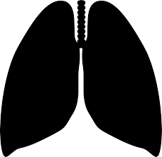 | What is the Respiratory System?
 | The main function of the respiratory system is to provide gas exchange between the blood and the air.

Explore
Read the article and answer the questions. https://kidshealth.org/en/kids/lungs.html
- According to the article, what do you lungs help you do?

- What is another name for the trachea?

- What is at the end of the trachea? Where do they lead?

- How many bronchioles are in each lung?

- Explain how oxygen gets from the outside air into your bloodstream.

Explain
Watch this video and answer the questions. https://www.youtube.com/watch?v=0giiDDBJVQU
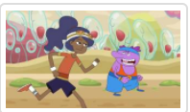

- What systems are the heart and blood in?

- What organ/s does the respiratory system start with?

- Why do we breathe faster? What gas do we need?

- What is the trachea?

- What is the diaphragm?

- What are alveoli important to the respiratory and circulatory system?

Elaborate
- What is the purpose of the respiratory system?

- Explain how oxygen gets to your cells and waste gets out through the circulatory and respiratory systems.

Early Finishers
Use this link to access a respiratory system simulation. Then answer the questions below.

- What does the simulation model?
- What systems do you see working together?
- What do you see happening at the alveoli?
- Name three organs that you see?
- Which gas is represented in red? Blue?

