Unit 10 South East Asia Vocabulary Week 1 - China & Japan
In the first box write each term, and in the second box write down the definition fully. Use the Powerpoint and watch the video of the vocabulary for secret answers for the quiz and extra points on the assignment. Remember all these terms have to do with South East Asia (China & Japan).

1.
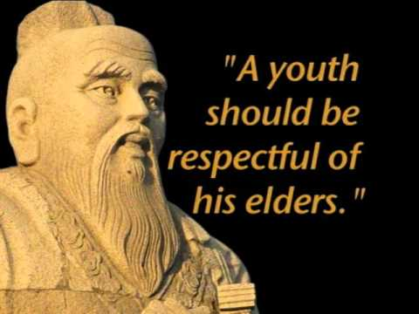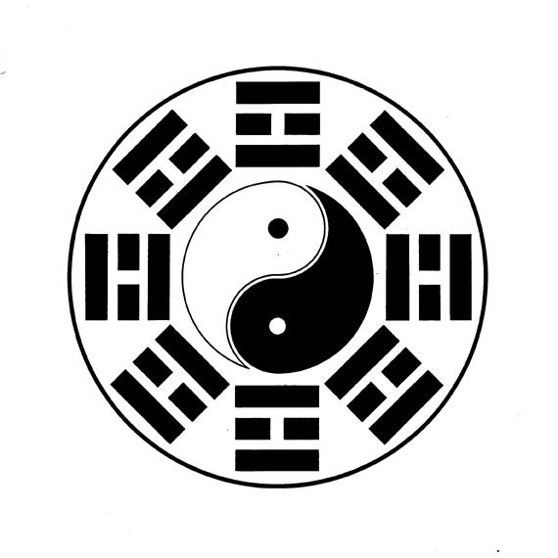
HINT: Philosophies
(The Term) | (Proper Definition)

2.
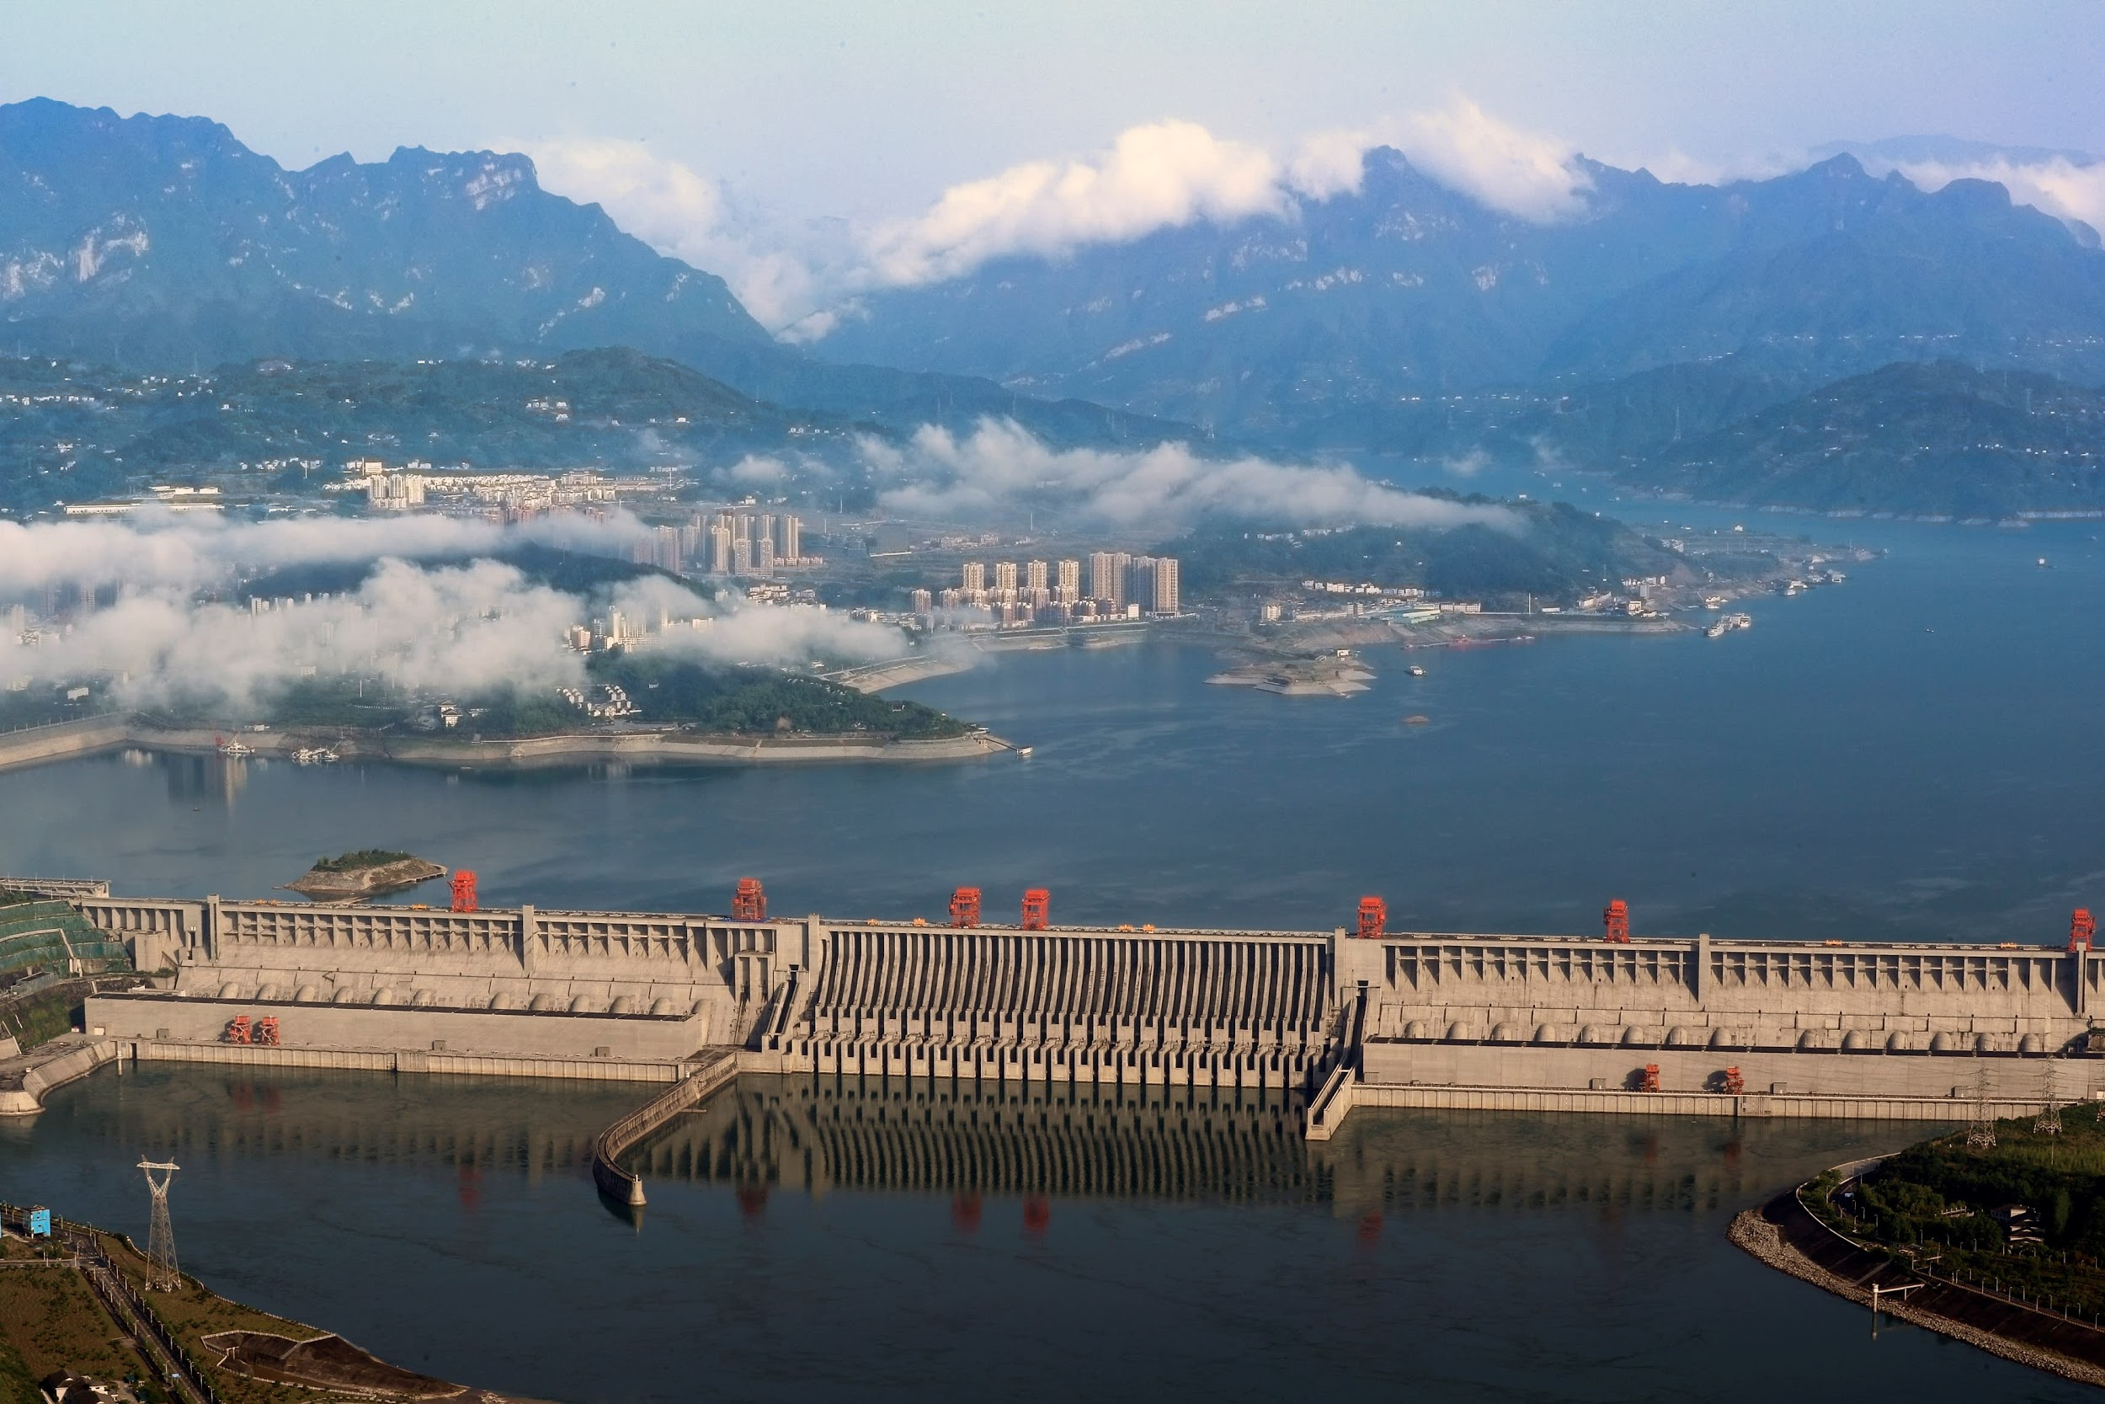
HINT: Hydro-electric Power
(The Term) | (Proper Definition)
3.
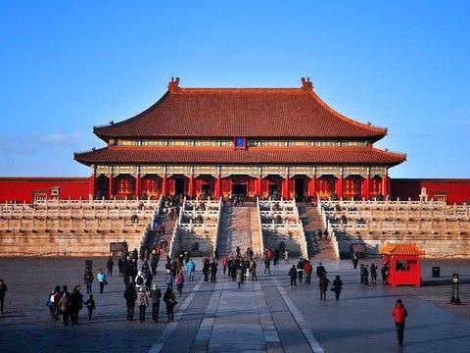
HINT: Home of the Chinese Emperor
(The Term) | (Proper Definition)
4.
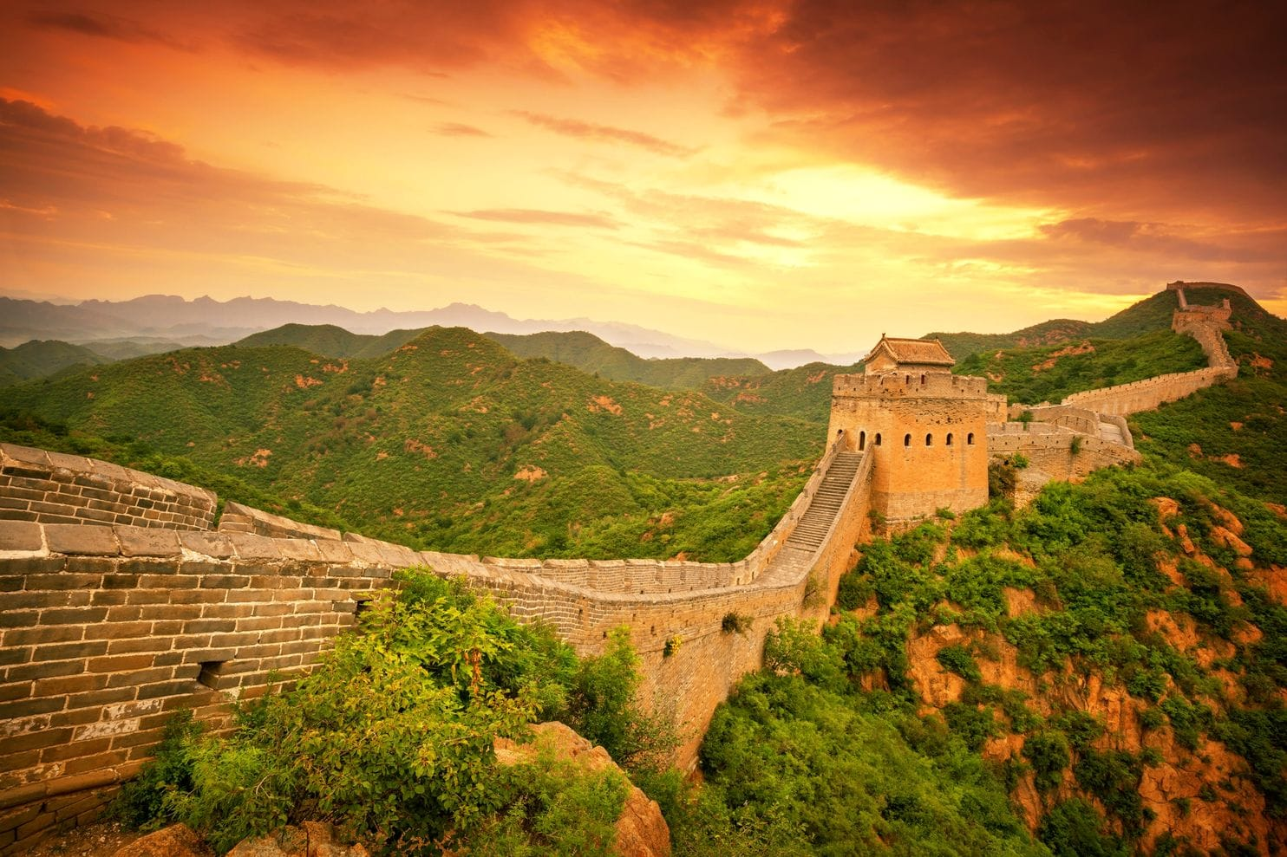
HINT: Can Be Seen From Outer Space
(The Term) | (Proper Definition)

5.
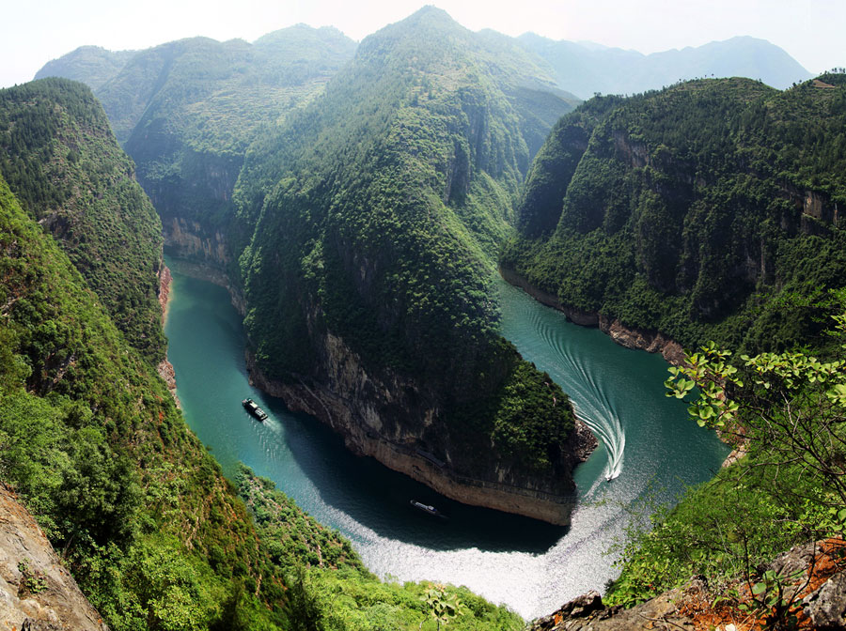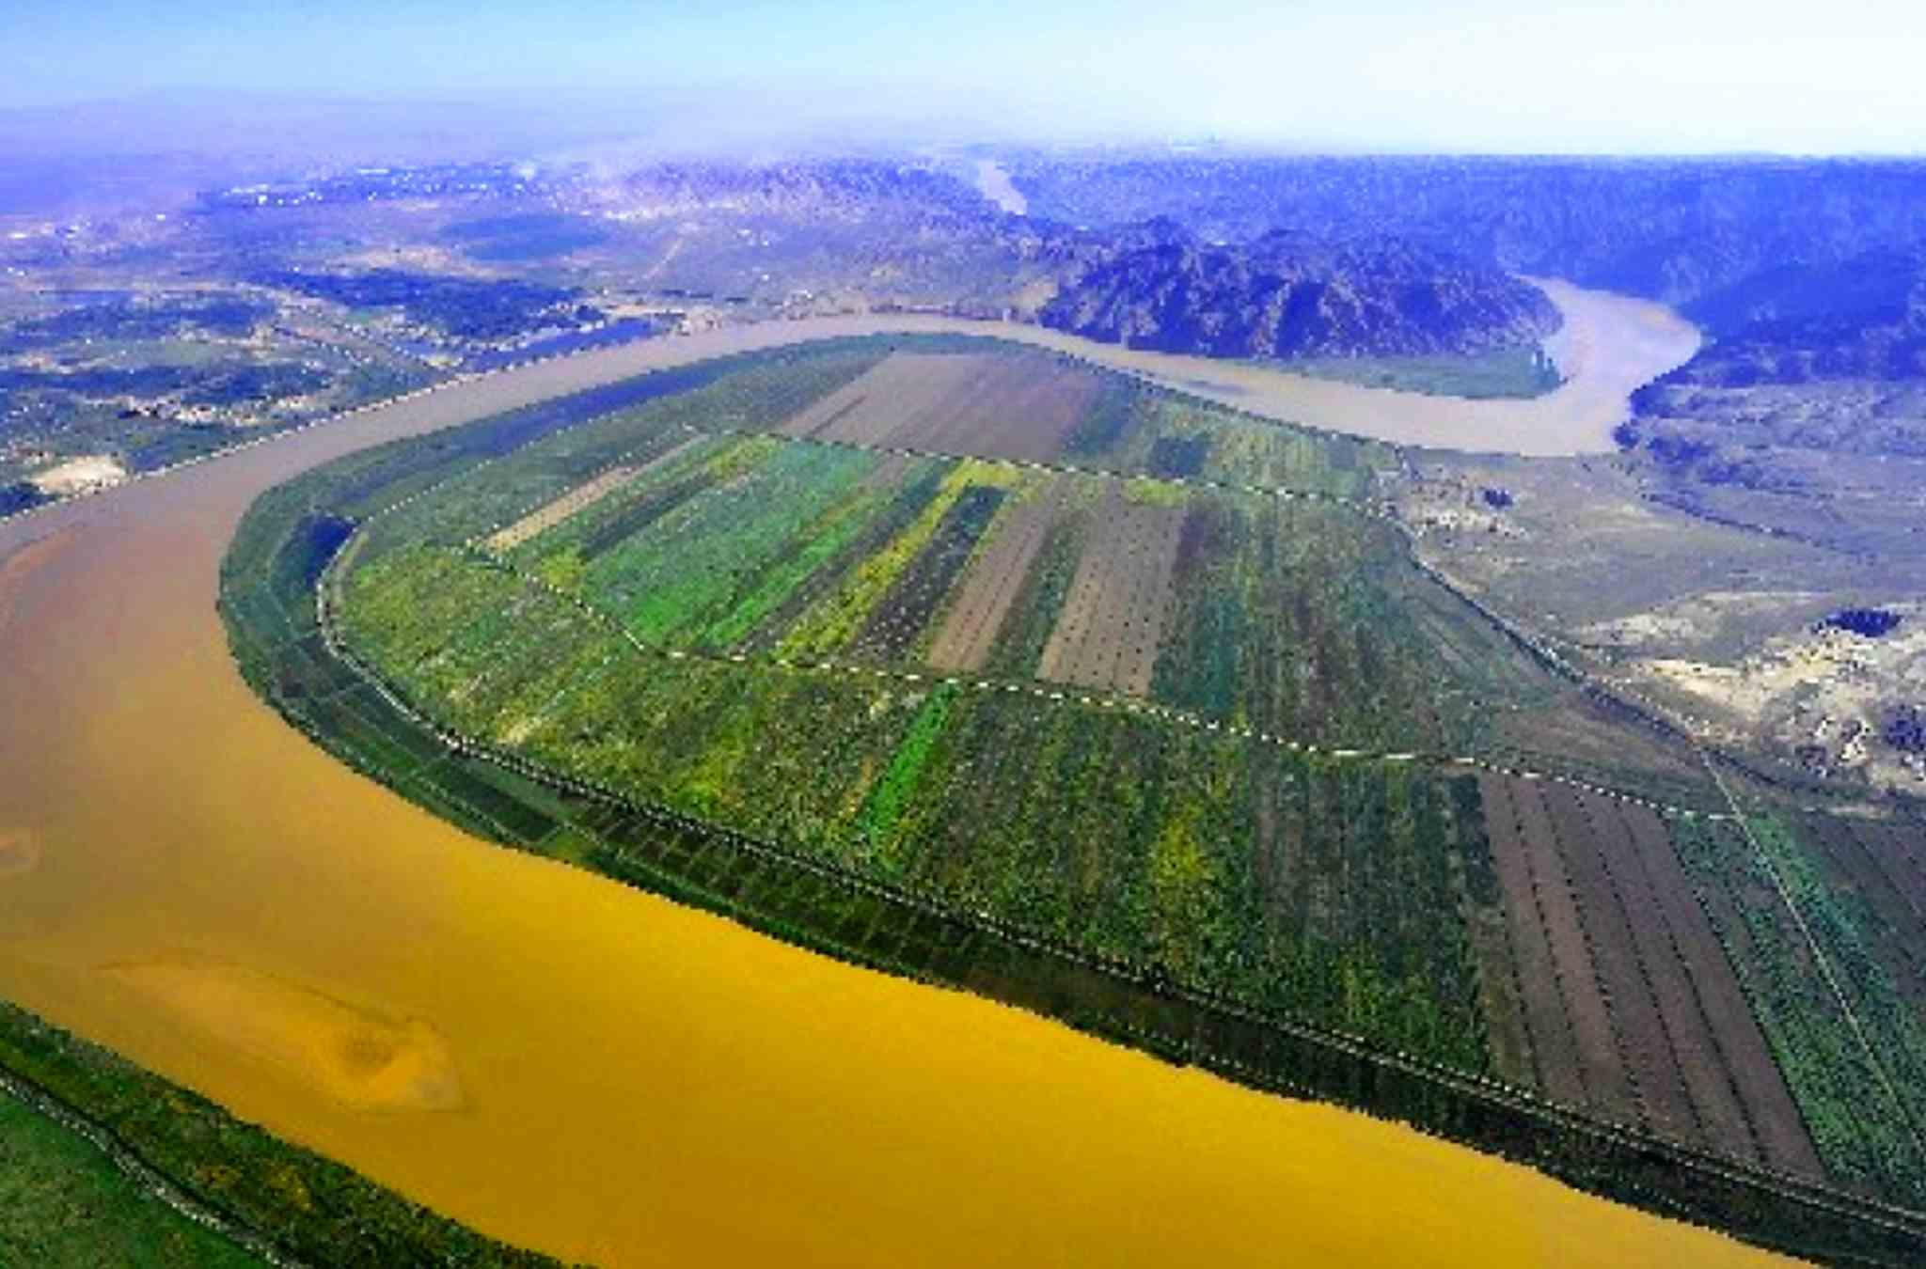
HINT: Mighty Rivers
(The Term) | (Proper Definition)
6.
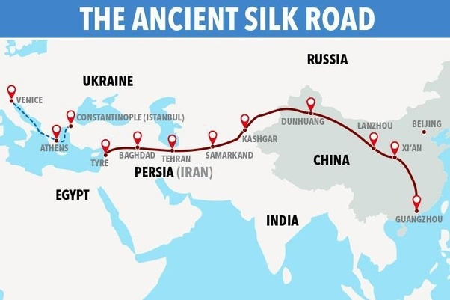
HINT: Ancient Trade Road
(The Term) | (Proper Definition)

7.
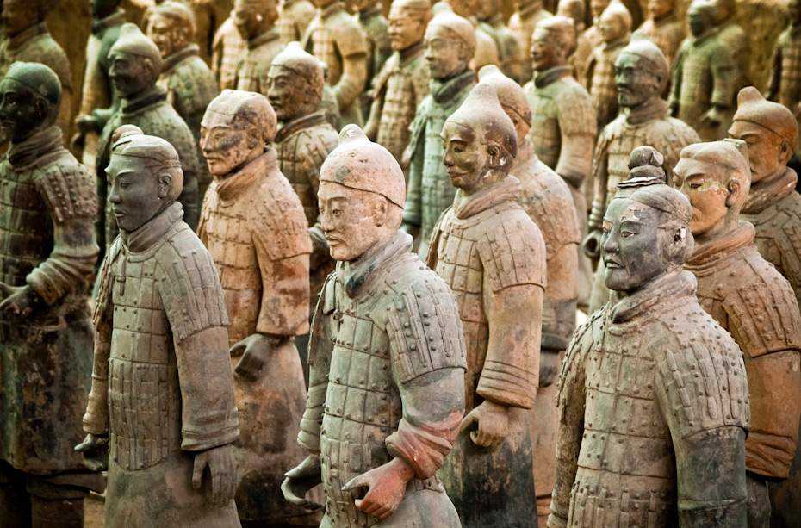
HINT: Warriors of Stone
(The Term) | (Proper Definition)

8.
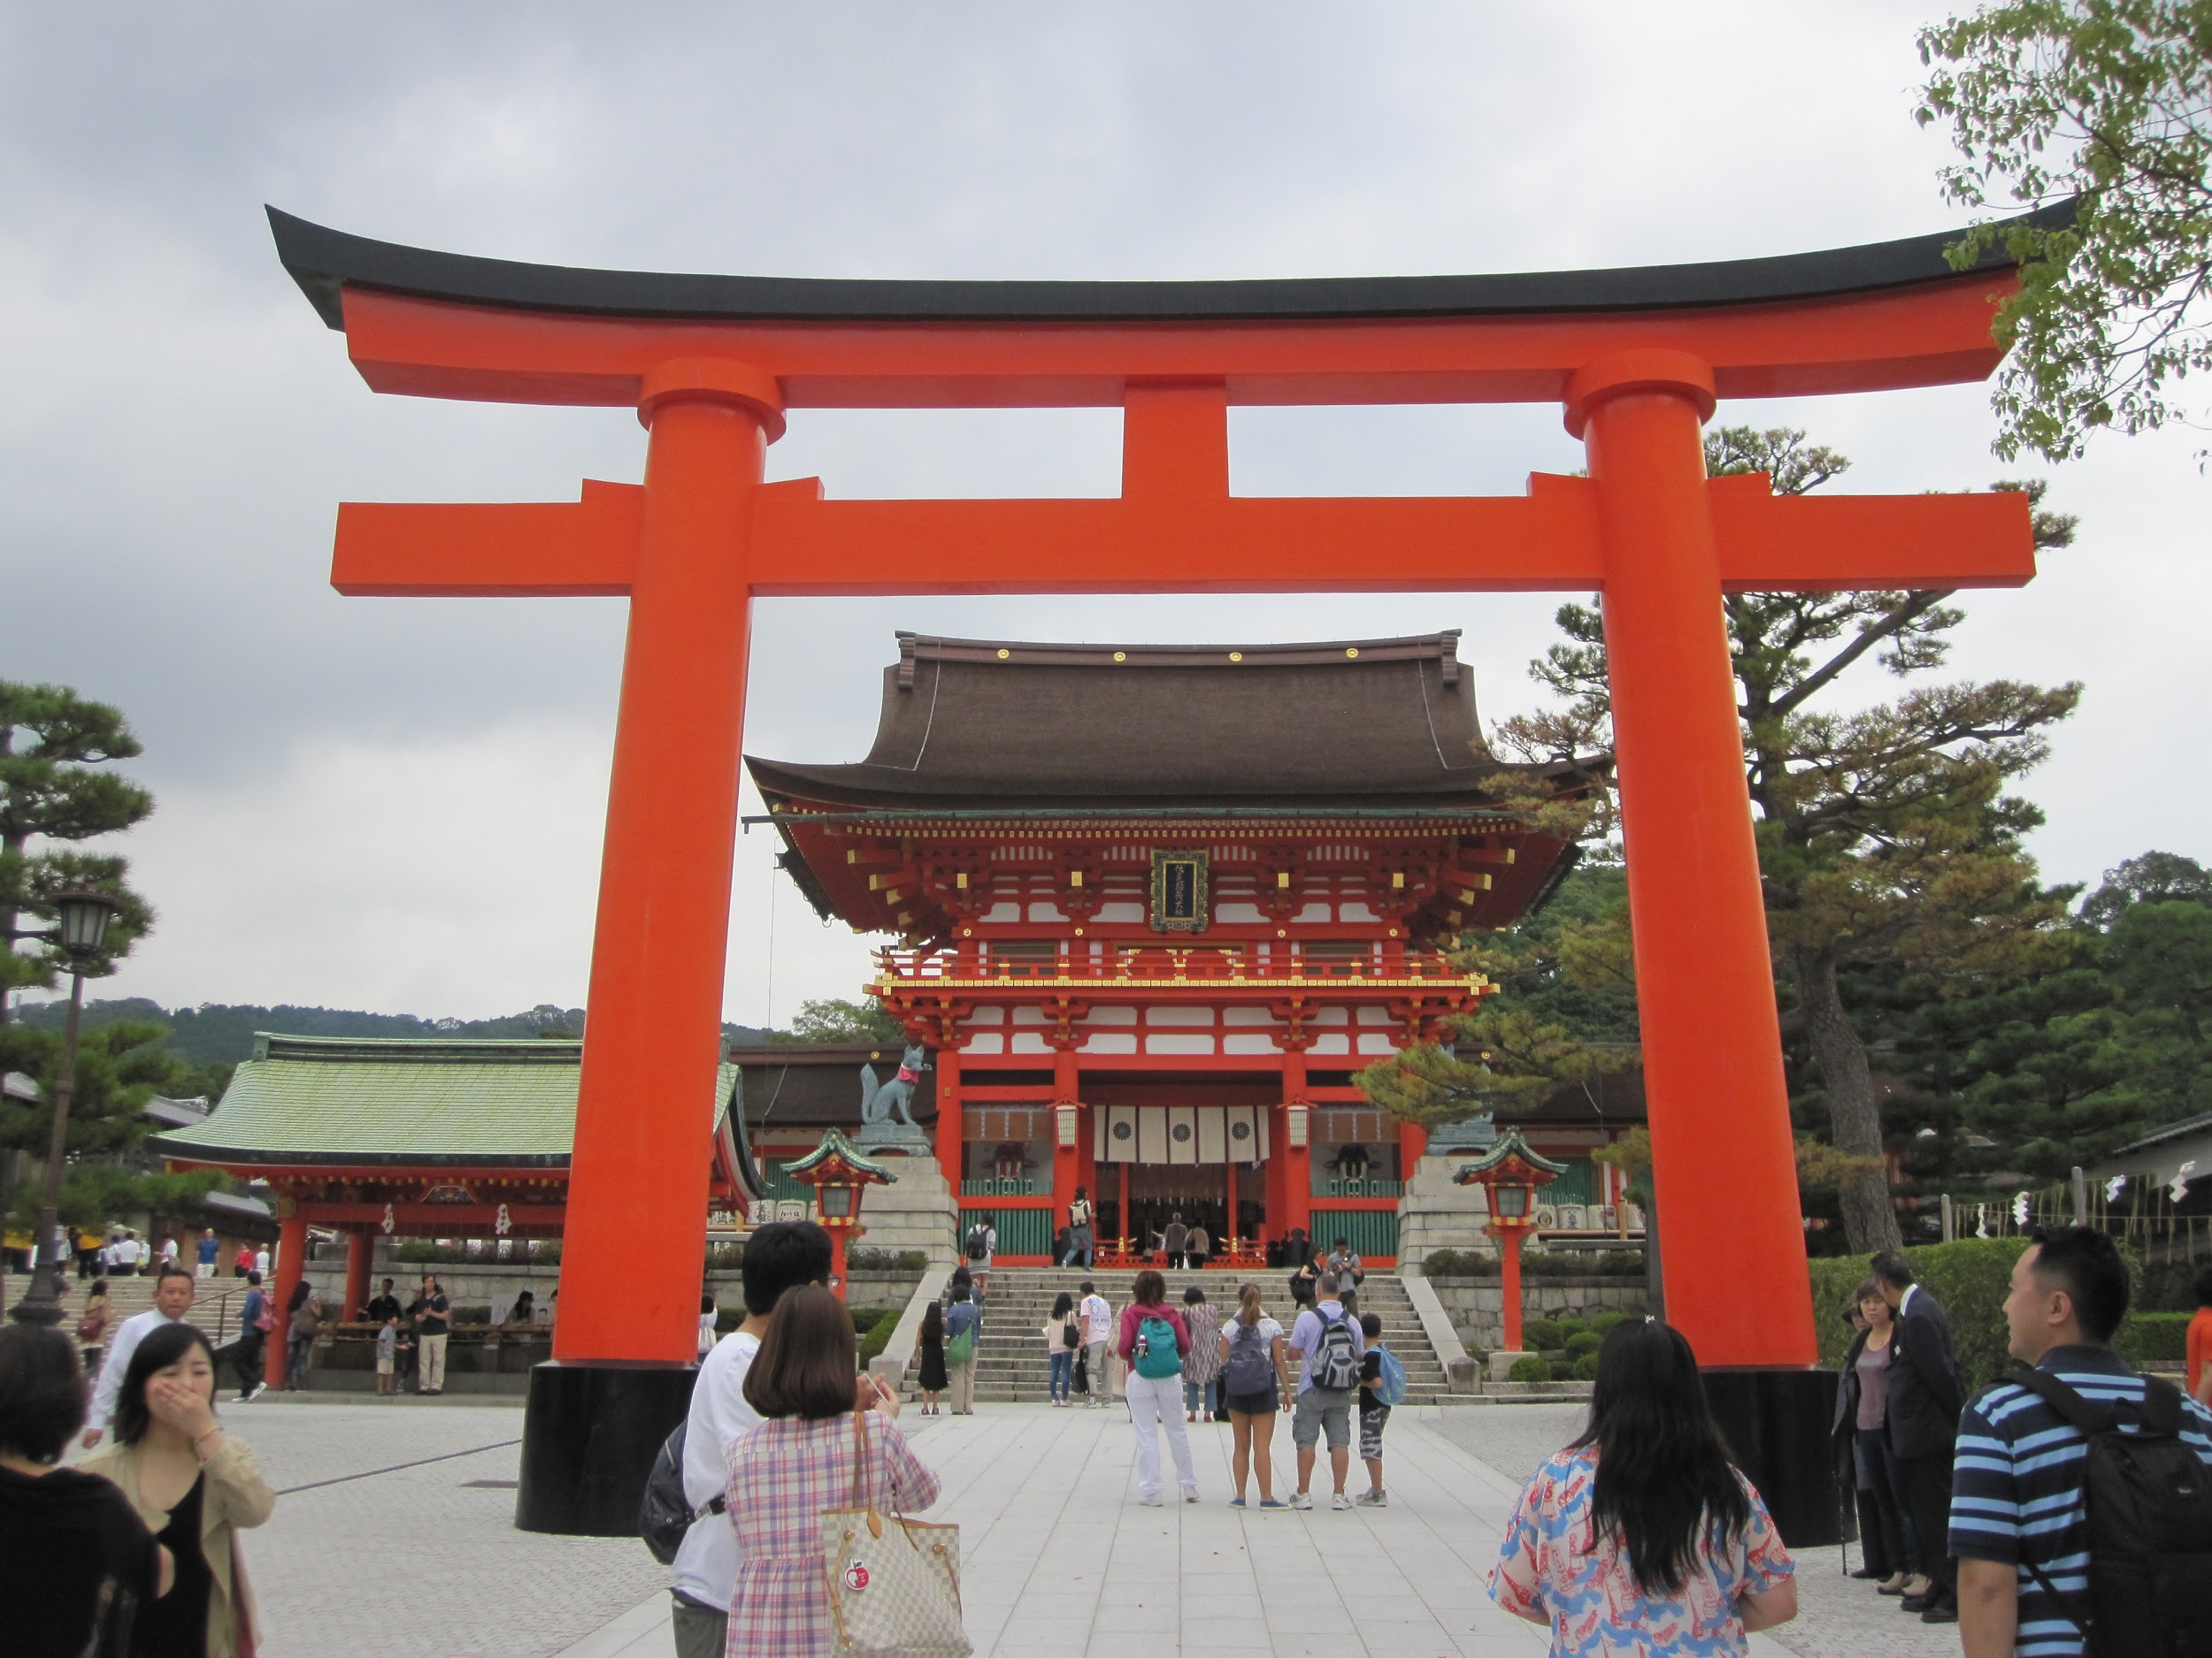
HINT: Japanese Religion
(The Term) | (Proper Definition)

9.
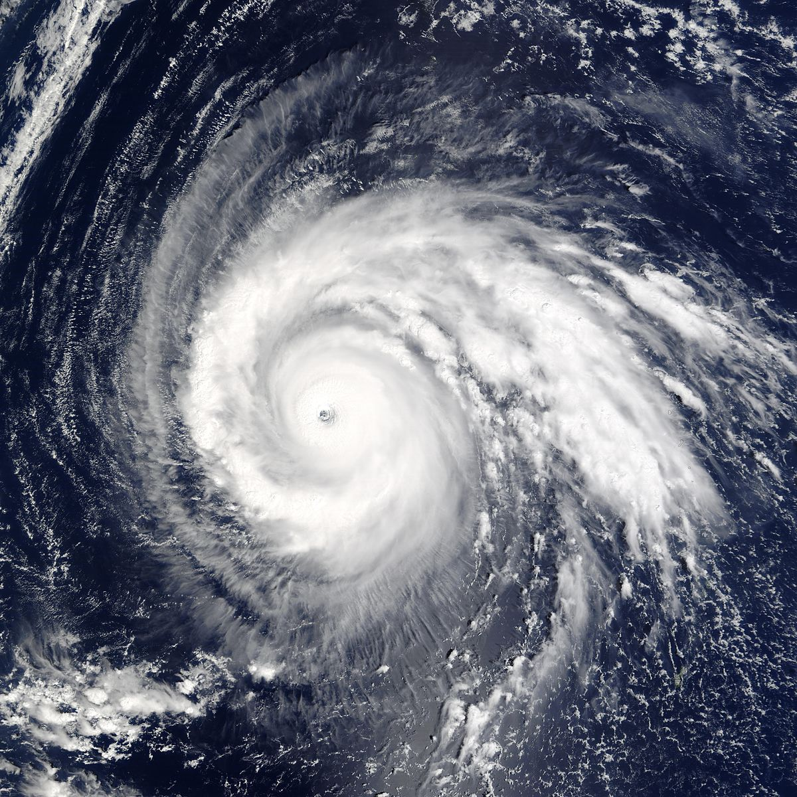
HINT: Weather
(The Term) | (Proper Definition)

10.
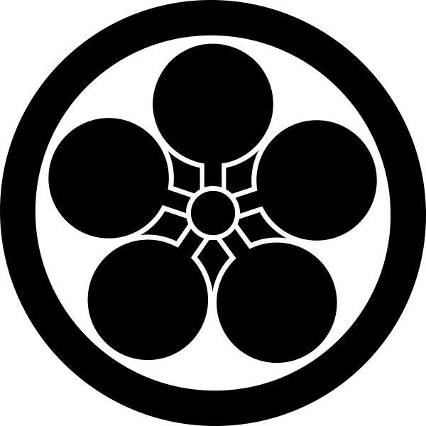
HINT: Female created this….
(The Term) | (Proper Definition)

11.
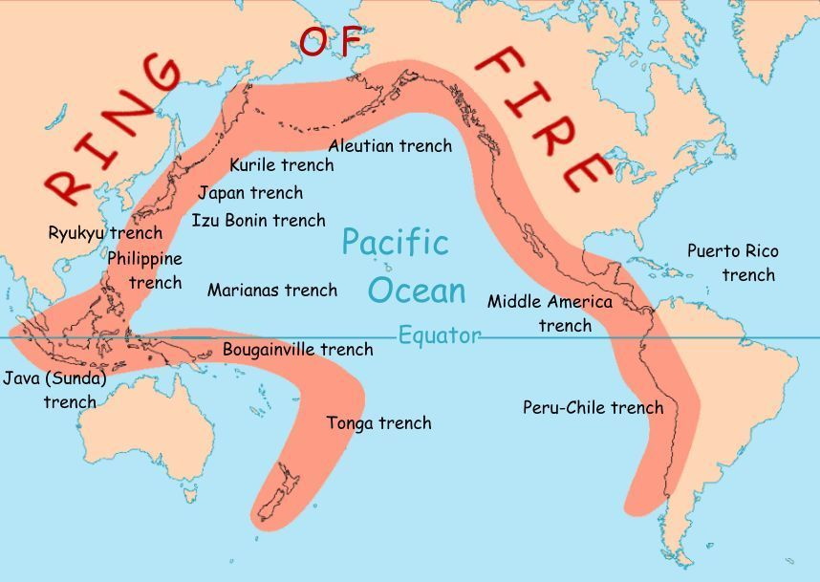
HINT: Volcanoes, Lava and Earthquakes..Oh my!
(The Term) | (Proper Definition)

12.
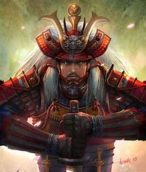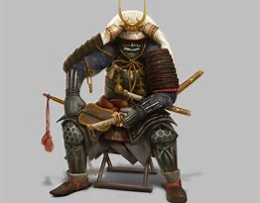
HINT: Thieves, Warriors & Warrior Kings
(The Term) | (Proper Definition)
13.
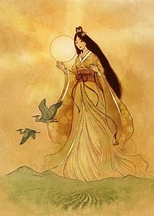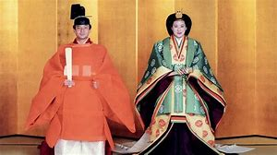
HINT: Creator and Ruler of Japan
(The Term) | (Proper Definition)
14.
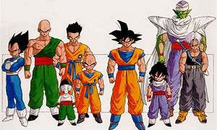
HINT: Your favorite cartoon style
(The Term) | (Proper Definition)

15.
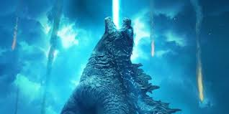
HINT: Famous Movie Monster
(The Term) | (Proper Definition)

