The Nervous System
Complete the activities in this order. | As you do the activities answer these questions.  Type your answers in a different color.
Watch and Listen | - What are the two parts of the nervous system?  - What organs are in the central nervous system?  - What organs are in the peripheral nervous system?  - How many parts does the brain have?  - Which is the largest part? What does it control?  - What is the 2nd major part of the brain? What does it control?  - What is the last major part of the brain? What does it control?  - What is the peripheral nervous system made of?  - What is the function of the peripheral nervous system?
Read  Click the image to access the link. | - What is the nervous system?  - What protects the brain?  - What are 3 ways to keep your nervous system healthy?
Identify
Name the parts of the brain. Answer on the right.  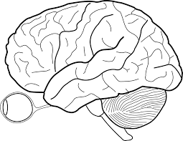  1.  2.  3. | - .  - .  - .
Question?

Do you have any questions or misunderstandings about the nervous system?
EXPLAIN
QUESTION ANSWER
How does the nervous system help you to survive?
Which part of the brain controls the five senses? How can that help with survival?
What organ connects the brain to the peripheral nerves?
Early Finisher
If you finish early, use the links to the right to learn more about the nervous system. | https://www.youtube.com/watch?v=zmXSDic2ce0  https://www.youtube.com/watch?v=ndDpjT0_IM0  https://quizlet.com/433801517/match

