Directions: Use the following images and information to complete the assignment on page 3.
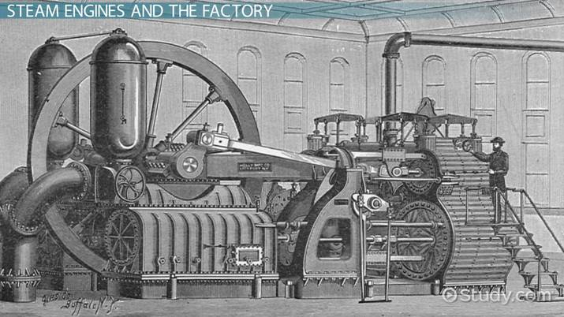 | The invention of the steam engine provided power for many different types of machinery. As a result, many factories were built in the Northern states.
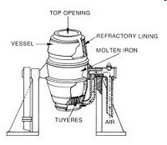 | The Bessemer Steel Process was used to create more durable metal. Steel was used in the production of guns and railroads.
 | Eli Whitney’s invention of interchangeable parts made the production of goods more efficient. Unskilled workers were able to make more goods at a faster rate.
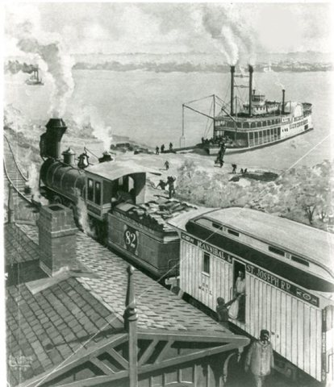 | Trains and Steamboats allowed for more efficient transportation across the United States. This allowed for an increase in the population in the western states and territories.
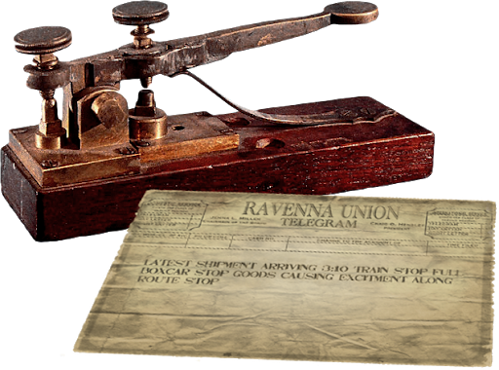 | Samuel Morse’s invention of the telegraph allowed for more efficient communication across the United States. People were able to communicate further distances at a faster rate.
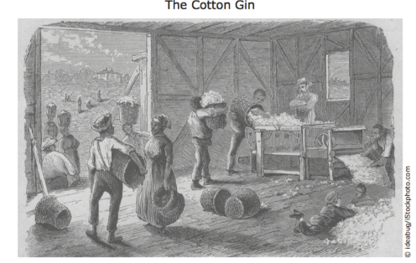 | Eli Whitney’s invention of the Cotton Gin increased the production of good, but it also increased the demand for slaves. Slavery increased in the southern states throughout the 1800’s.

Directions: Choose an invention of the Industrial Revolution that you believe had the biggest impact on the United States. After you have chosen your invention, explain in 3 to 5 sentences what the invention did and why it had such a big impact on the United States. Then, create a visual representation of what the invention did and how it impacted the United States.
Explanation of the invention you chose: | Visual of the invention you chose:

