Unit 10 South East Asia Vocabulary Week 2 - North & South Korea
In the first box write each term, and in the second box write down the definition fully. Use the Powerpoint and watch the video of the vocabulary for secret answers for the quiz and extra points on the assignment. Remember all these terms have to do with South East Asia (North & South Korea).

1.
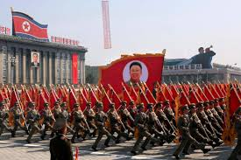
HINT: Communism
(The Term) | (Proper Definition)

2.
HINT: The tale of two Koreas
(The Term) | (Proper Definition)
3.
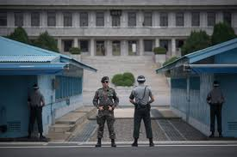
HINT: The Dividing Line (38th Parallel)
(The Term) | (Proper Definition)
4.
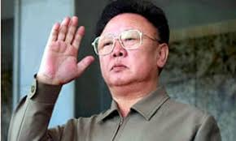
HINT: Dictator who thought he was the Korean Elvis
(The Term) | (Proper Definition)

5.
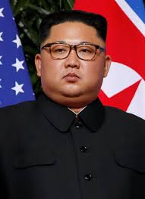
HINT: The new leader
(The Term) | (Proper Definition)
6.
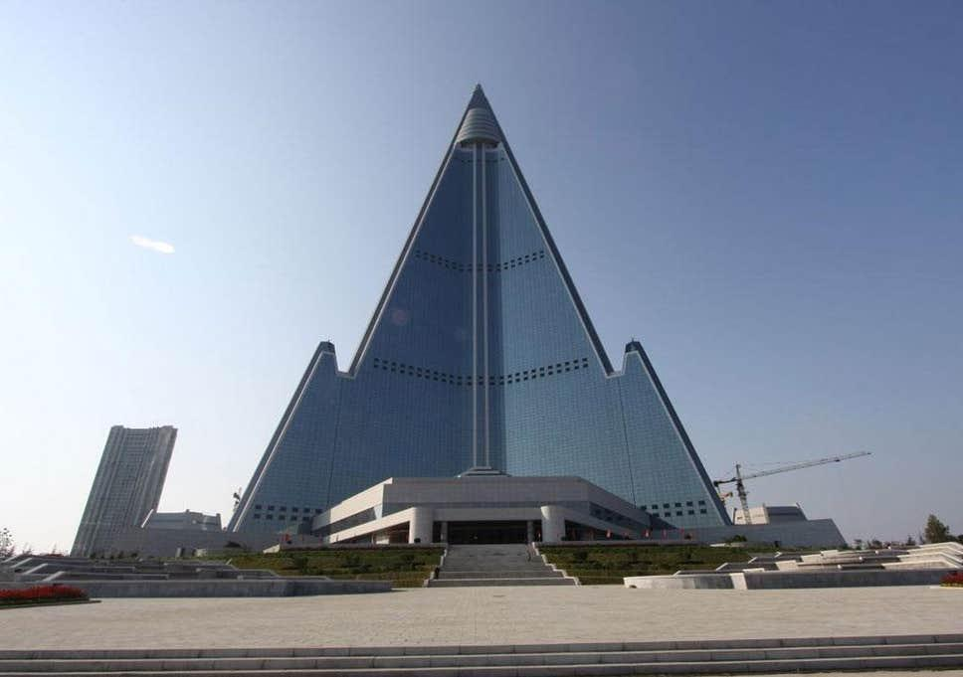
HINT: Fake Skyline
(The Term) | (Proper Definition)

7.
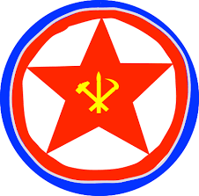
HINT: Korean Religion
(The Term) | (Proper Definition)
8.
HINT: Popular Classic TV Show
(The Term) | (Proper Definition)

9.
HINT: Awesome Shopping
(The Term) | (Proper Definition)
10.
HINT: K-Pop
(The Term) | (Proper Definition)
11.
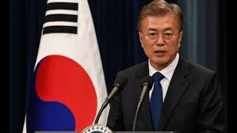
HINT: President
(The Term) | (Proper Definition)
12.
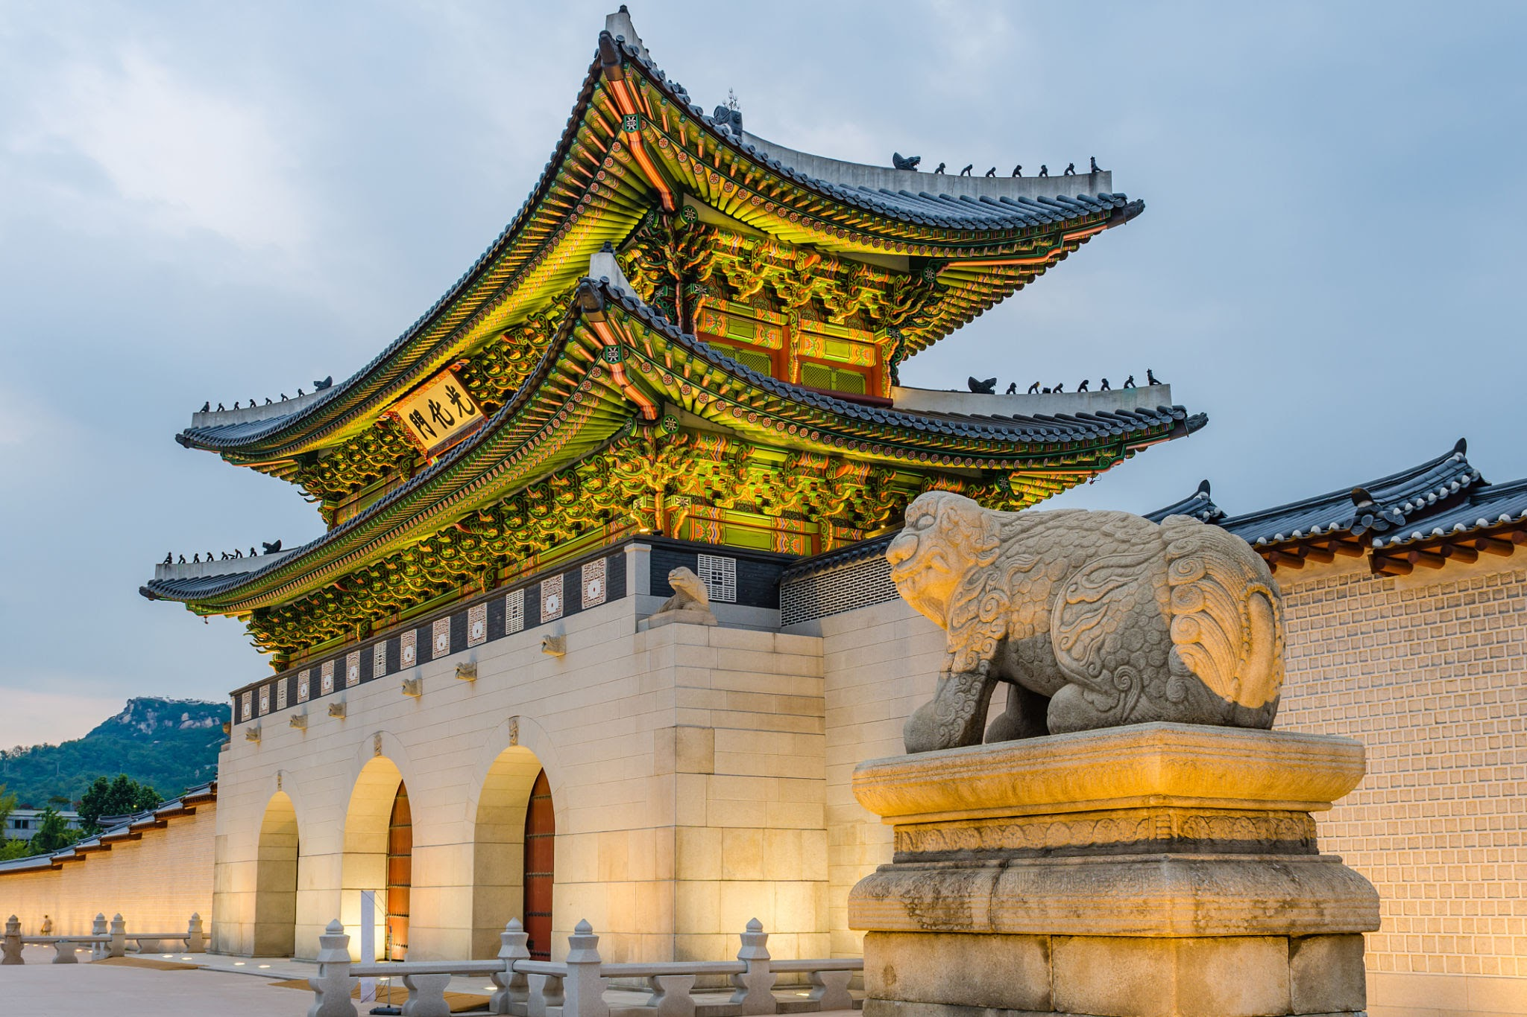
HINT: Ancient Palace
(The Term) | (Proper Definition)

