Primary Source: World War II
After reading the article below you will need to complete the 2 directives that follow the article.

Oak Ridge, "the Secret City" that ended World War II
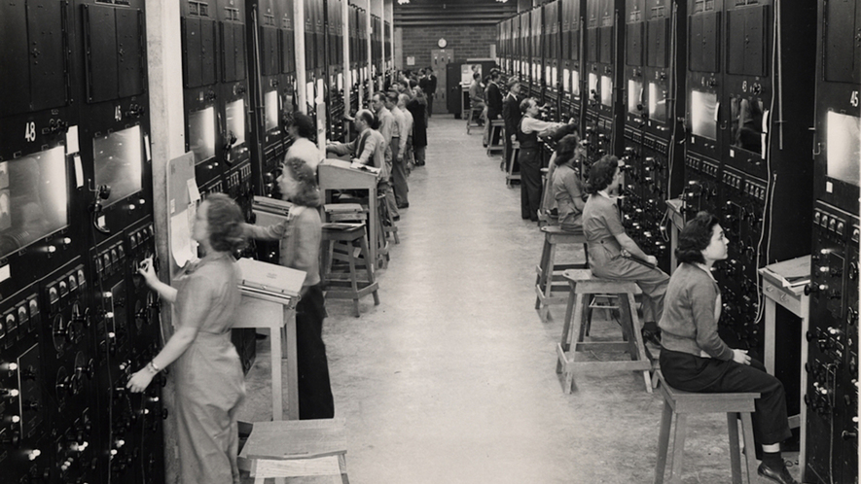

Image 1. The Manhattan Project, shown in this photograph from 1944, was one of the most secretive operations in U.S. history. Oak Ridge, Tennessee, served as the base of this project, which sought to research and create nuclear weapons during World War II. Photo: National Archives and Administration/National Archives at Atlanta

By Atlas Obscura
Oak Ridge, a town once hidden in secrecy in the hills of Tennessee, continues to fascinate people to this day. Part of the top-secret Manhattan Project, the "Secret City" has a rich history of world-changing science and research that helped end World War II and has earned itself international recognition with continued advances in science.
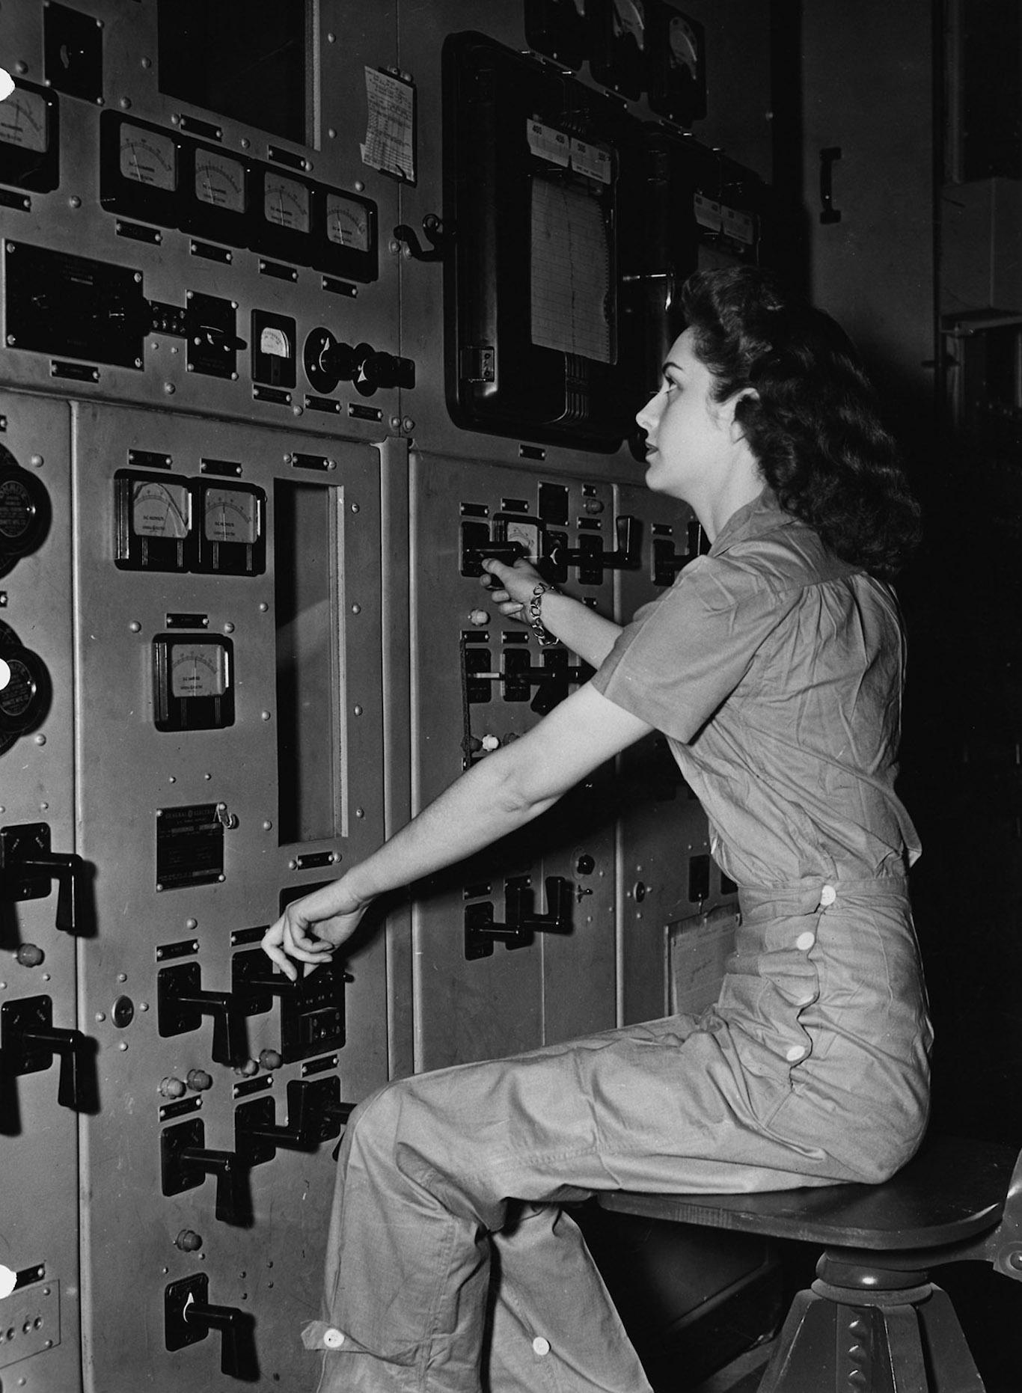
Established by the U.S. government in 1942, to serve as a home base to the Manhattan Project and chosen for its remote locale, the entire city had to be built almost from scratch to handle the influx of employee-residents, which ballooned form 3,000 to 75,000 within three years. Very few of the employees, most of whom were women, knew what was being built at the time, or exactly what they were getting into.

Image 2. Many employees at the Manhattan Project, including the woman photographed here around 1944, had little to no understanding of how their work contributed to nuclear research. Photo: National Archives and Administration/National Archives at Atlanta.

Delightful Oak Ridge was, in a lot of ways, just like any quaint southern city — there was an abundance of leisure activities like swimming, a library, 13 grocery stores, an orchestra and swing dancing. Besides the required badges, guard towers and giant perimeter fence, it was practically a wartime Mayberry. Everyone was quarantined, and their duties left the actual project a mystery, but who would want to leave when they have everything right where they're at, and who were they to question the government who had given them such a comfortable home and stable employment? It wasn't until Americans dropped the atomic bomb on Japan that the fine citizens of Oak Ridge realized what they had become a part of.
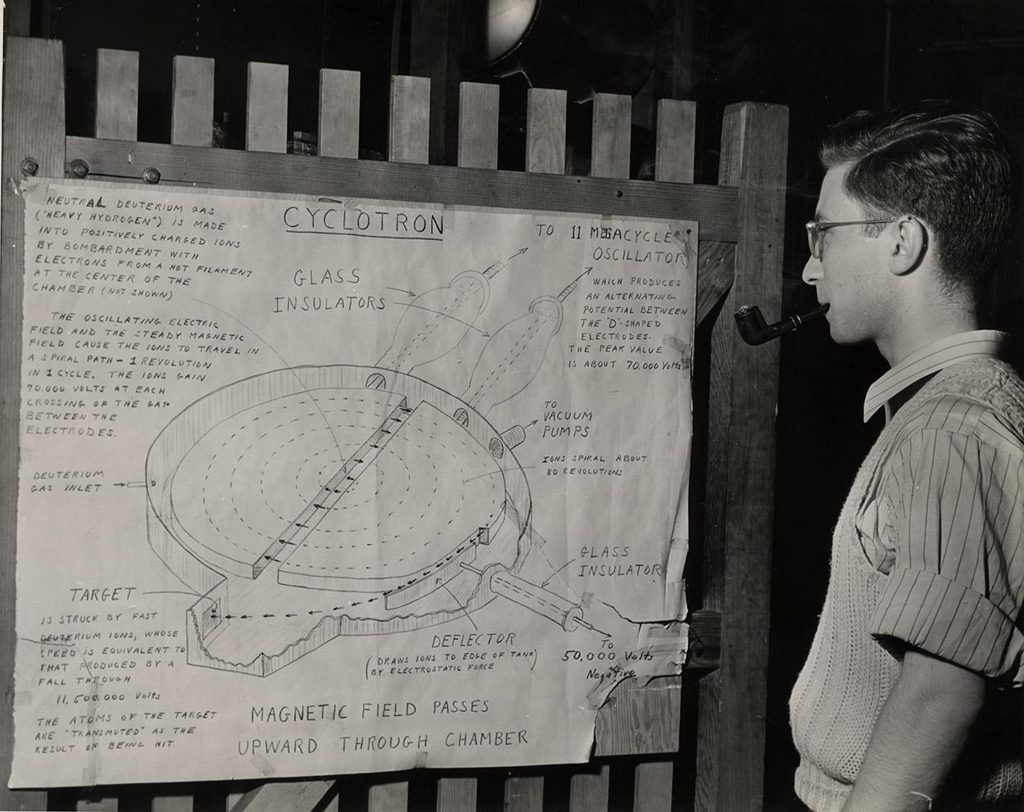
But what many don't know is that Oak Ridge's legacy was predicted nearly 40 years earlier before tensions ever began in Europe, with tales of legend and folklore that not only turned out to be true, but sealed the Secret City's place in history.

Image 3. A scientist studying a cyclotron diagram around 1944. Cyclotrons were designed to separate isotopes in uranium, an important part of the process for creating nuclear bombs. Photo: National Archives and Administration/National Archives at Atlanta.

On the highest point in the Hendrix Creek Subdivision in Oak Ridge lies a vacant lot with a quiet, single gravestone that marks the final resting place of John Hendrix. Around the turn of the 20th century, having just lost his youngest daughter, Ethel Hendrix, to diphtheria, Hendrix was beside himself in misery. His wife, Julia Ann Hendrix, had just left him and took off with his three other children to Arkansas. Having sent a letter confirming she would never return and seemingly blaming him for Ethel's death, Hendrix slipped into despair, turning to faith and prayer for salvation.
As the story goes, during one prayer, he heard a loud voice telling him to sleep on the ground for 40 days and nights, and if he did this he would soon learn the future of Bear Creek Valley. On the 41st morning, he emerged from the woods with detailed visions and told any and all passersby that:
"Bear Creek Valley someday will be filled with great buildings and factories, and they will help toward winning the greatest war that ever will be."
"There will be a city on Black Oak Ridge, and the center of authority will be on a spot that is middle-way between Sevier Tadlock's farm and Joe Pyatt's place."
"A railroad spur will branch off the main L&N line and run down toward Robertsville, and then it will branch off and turn toward Scarboro."
"Big engines will dig big ditches and thousands of people will be running to and fro. They will be building things, and there will be great noise and confusion, and the earth will shake. I've seen it; it's coming."
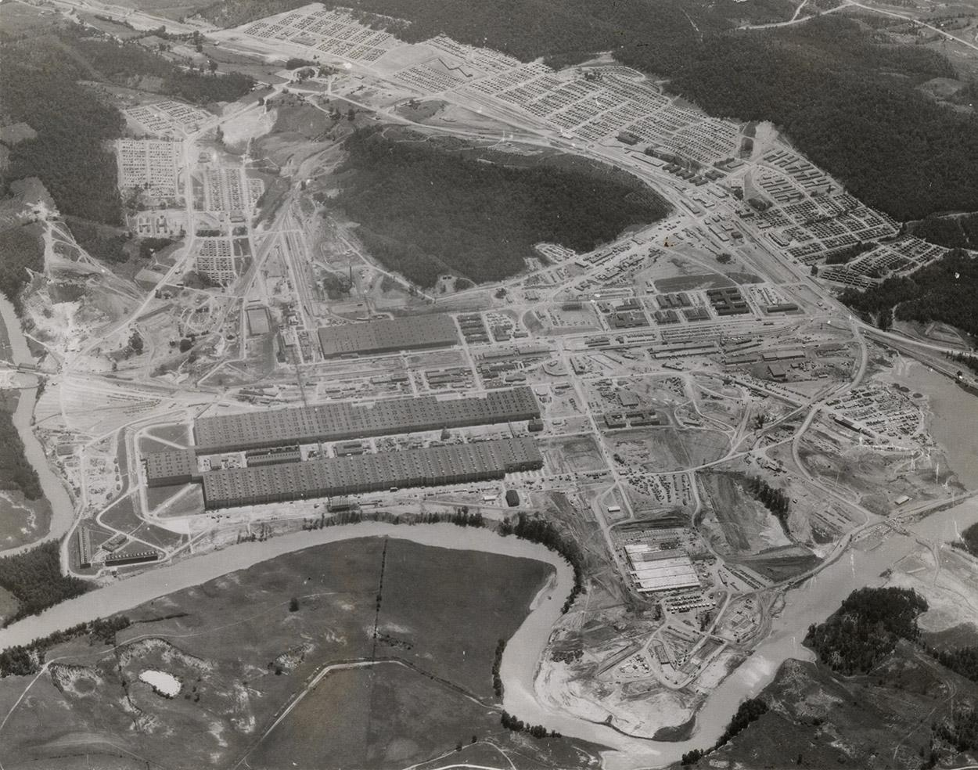
These predictions were accurate down to the exact location. Nearly 30 years after his death in 1915, the iconic uranium processing facilities that changed the course of history during World War II were erected in Bear Creek Valley. Y-12, K-25, S-50 and the X-10 Graphite Reactor were constructed in just 18 months. Some of these buildings produced uranium-235, which fueled the first atomic bomb that contributed to ending the great war.

Image 4. Aerial photograph of K-25, one of the large facilities built in Oak Ridge as a part of the Manhattan Project. Photo: National Archives and Administration/National Archives at Atlanta.

The south slope of Black Oak Ridge eventually became the birthplace of the city of Oak Ridge. The area between Tadlock's and Pyatt's place did, in fact, become the center of authority for Oak Ridge during the Manhattan Project era. The railroad spur was laid out exactly where Hendrix said it would be, and approximately 75,000 people called Oak Ridge home during the height of the war effort.
Hendrix's descendants also tell of other things he predicted, such as "cargo would be transported through the air," and this was before there were any airplanes. They also remember him saying, "when they cut that right of way for the railroad spur, they will split a tree." His granddaughter said they kept a small half-stump painted white for years.
Two years after WWII ended, the city was relinquished to civilians. When visiting the city today, you can still see some of the old guard towers on the edges of the city, and experience one of the nation's largest swimming pools still in operation.

Directive #1

Write a paragraph that explains the central idea of the text. Use at least two details from the article to support your response.
Insert your text box here:

Directive #2

Answer the following 4 Multiple-choice questions by highlighting the correct response.
#1
Read the following sentence from the article.
But what many don't know is that Oak Ridge's legacy was predicted nearly 40 years earlier before tensions ever began in Europe, with tales of legend and folklore that not only turned out to be true, but sealed the Secret City's place in history.
Which selection from the article BEST supports this idea?
- A
- It wasn't until Americans dropped the atomic bomb on Japan that the fine citizens of Oak Ridge realized what they had become a part of.
- B
- As the story goes, during one prayer, he heard a loud voice telling him to sleep on the ground for 40 days and nights, and if he did this he would soon learn the future of Bear Creek Valley.
- C
- These predictions were accurate down to the exact location. Nearly 30 years after his death in 1915, the iconic uranium processing facilities that changed the course of history during World War II were erected in Bear Creek Valley. Y-12, K-25, S-50 and the X-10 Graphite Reactor were constructed in just 18 months.
- D
- When visiting the city today, you can still see some of the old guard towers on the edges of the city, and experience one of the nation's largest swimming pools still in operation.

#2
Read the following selection from the article.
Everyone was quarantined, and their duties left the actual project a mystery, but who would want to leave when they have everything right where they're at, and who were they to question the government who had given them such a comfortable home and stable employment? It wasn't until Americans dropped the atomic bomb on Japan that the fine citizens of Oak Ridge realized what they had become a part of.
Which of the following conclusions can be drawn from the selection above?
- A
- The citizens of Oak Ridge frequently questioned the government regarding the specifics of the mysterious project.
- B
- Oak Ridge was designed to keep its residents content and unaware of what they were creating.
- C
- The citizens of Oak Ridge felt pride regarding their involvement in the government's secret project.
- D
- Oak Ridge was designed like a prison to prevent citizens from being able to leave.

#3
Read the following summary of the article.
The city of Oak Ridge was built in the hills of Tennessee during World War II. Its primary focus was developing weapons of mass destruction that would change the course of history and devastate an entire country. The government dishonestly tricked people into moving to the new city, and then immorally enticed them to stay there by providing stable incomes and ideal amenities. As it turns out, original citizen John Hendrix predicted exactly how the city would transform years prior to the war efforts.
Is this an objective and accurate summary? How do you know?
- A
- Yes; it concisely explains without judgment how the government manipulated the workers of Oak Ridge.
- B
- No; it does not include specific details about the various amenities the city provided for its citizens.
- C
- Yes; it ties John Hendrix's predictions to the reality of the city's development.
- D
- No; it presents an overly biased view of the government's relationship to the citizens of Oak Ridge.

#4
Read the following central idea statements.
- John Hendrix accurately predicted the development of Oak Ridge years prior to the government's establishment of the city.
- Oak Ridge experienced a dramatic increase in population growth during the time of the Manhattan Project.
- Oak Ridge developed world-changing science and research that helped end World War II.
- John Hendrix's incredible predictions are solidified as a part of Oak Ridge's history with a gravestone marker at the city's highest point.
Which two options MOST accurately reflect the central ideas of the article?
central ideas of the article?

- A
- 1 and 3
- B
- 1 and 4
- C
- 2 and 3
- D
- 2 and 4

