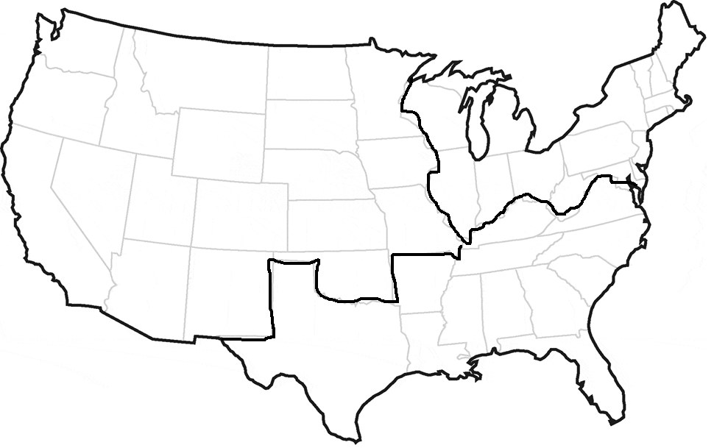
Sectionalism
Map activity
North
South
West

Name: ________________________________________________________ Period: __________ Date: ________________________

Sectionalism Map Activity

Part 1. Sectionalism Chart
Directions: Place each description under the correct region of the United States. Some words may be used more than once.

Canals | Agriculture | Cheap Land | Gold Rush | Urbanization (cities)
Railroads | Protective Tariffs | Slavery | Trade & Shipping | Plantations
Cotton | Better Roads | Factories | Tobacco | Frontier Farms
Steam boats | Fishing/Whaling | Fur Traders | Anti-slavery | Manufacturing

North | South | West
Part 2. Sectionalism Map Characteristics
Directions: Label each region of the United States, and use the chart you filled out on the front side of this page to draw symbols that show the characteristics of each region.

