SEVEN PRINCIPLES OF GOVERNMENT
Each statement below illustrates one of the seven principles of the Constitution. Read each statement and identify the principle involved. Use pages 133 – 135 in the Mastering 8th Grade Social Studies TEKS workbook for definitions of each principle.
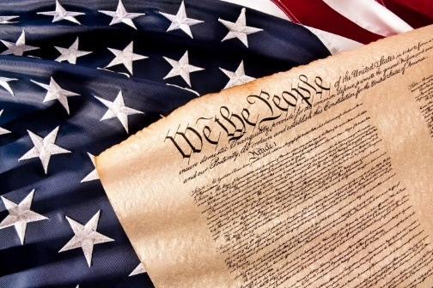
Popular Sovereignty
Republicanism
Limited Government
Federalism
Separation of Powers
Checks and Balances
Individual Rights

1. __________________________ The power to govern comes from the people.

2. __________________________ The people elect representatives to make laws and conduct government.

3. __________________________ Congress makes laws for the nation.

4. __________________________ The President and all other government officials must obey the law like all American citizens.

5. __________________________ Voters in Texas elected Ted Cruz to the United States Senate.

6. __________________________ Congress cannot make a law that violates freedom of speech.

7. __________________________ The powers of the national government are distributed among three branches of government.

8. __________________________ The government cannot arrest a person unless that person has violated a law.

9. __________________________ State and local governments supervise the public school system.

10. __________________________ The Senate can refuse to approve a treaty that the President has negotiated.

11. __________________________ The President can veto a bill that has been approved by the House of Representatives and the Senate.

12. __________________________ The President is commander in chief of the military.

13. __________________________ States can make marriage laws for their state.

14. __________________________ Congress passes a law forbidding abortions in all situations, but the Supreme Court declares it unconstitutional

15. _________________________ Congress can coin money.

