Political Cartoon – AP Human Geography

We will be doing a Political Cartoon for this week, since we are studying Religion. You can choose to make it about one of the religions, human behavior during the COVID-19 pandemic, lack of sports or online school. This will help you to document what is going on during this moment in human history. Remember, to keep the cartoon clean, meaning do not attack people, insult a particular race or gender, or animals. I am not expecting perfection just do your best. Use the Internet to get your images and make your comments. Use Google Slides to display your cartoons (Yes 3 of them)

Example: #1

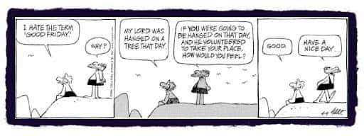
Example: #2
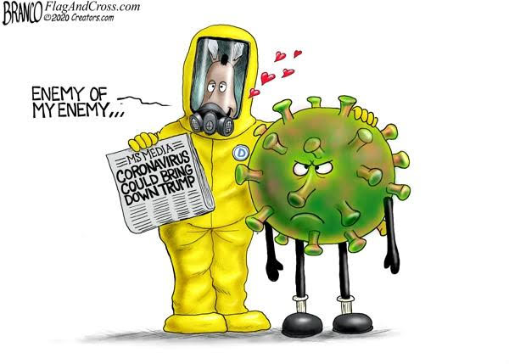Example: #3

