LET’S TRAVEL TO INDIA!
I. MATCH THE LANDMARKS USING
THE FOLLOWING CHOICES:
GOLDEN TEMPLE
TAJ MAHAL |  |  | b
RED FORT
AKSHARDHAM TEMPLE |  | a
LOTUS TEMPLE |  |  | DELHI
II. MATCH THE FOLLOWING ITEMS: |  |  | agra
1- JATI | 3- ARYABHATTA
2- RUPEE | 4- MAHATMA GANDHI
THE INDIAN SCIENTIST THAT |  |  |  | calcutta
INVENTED THE DIGIT ZERO
OFFICIAL CURRENCY OF INDIA |  | mumbai
THE NATIVE TERM FOR THE HINDU |  |  |  | d
CASTE SYSTEM
THE MOST PROMINENT POLITICAL AND
SPIRITUAL LEADER DURING THE MOVE-
MENT FOR INDIA’S INDEPENDENCE IN
THE 20TH CENTURY |  |  | e
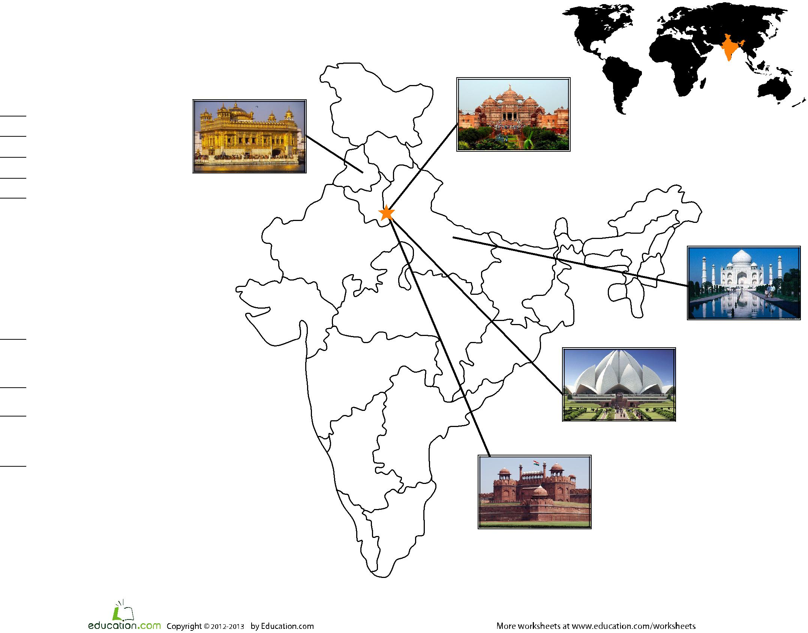

c

:

