Review: Atomic Structure
Directions: Work through the tasks below in order. You must type your answers into the boxes for each task, or complete the task as it is described. Your answers will be graded.
Order | Task
TEK 8.5A - describe the structure of atoms, including the masses, electrical charges, and locations, of protons and neutrons in the nucleus, and electrons in the electron cloud
Learning Target #1: Atoms are made of smaller pieces.

1 | Read about atoms here.  What are atoms?  Fill in the chart below from the website.  Atoms are made out of three basic particles:  Name of particle Charge Location Mass (click on Fun Facts)
2 | Use this Periodic Table to answer the following questions.  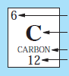  What four things are shown on the Periodic Table for each element? Label them on the elemental box below.  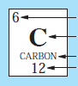  Type this answer here:  Type this answer here:  Type this answer here:  Type this answer here:  What number tells you how many protons are in the nucleus? _____________________________  When you add the protons and neutrons together it gives you the ________________________  What number tells you how many electrons are in the electron cloud? ____________________  How many protons does Carbon have? ________________________  How many neutrons does Carbon have? ________________________
3 | Watch this video to understand how to find the number of subatomic particles in an atom.  Fill in the chart below:  Element Atomic Number Mass Number of Protons Number of Neutrons Number of Electrons  oxygen  boron  hydrogen  carbon  nitrogen  sodium  lithium  If you need help, use this Periodic Table.
Learning Target #2: Atoms are pieces of elements, found on the Periodic Table.

4 | Read this article and answer the question that follows.  What is the difference between an atom and an element?
5 | Watch this video to help with the following questions.  How many electrons can go in the first energy level? _______  How many electrons can go in the second energy level? _______  How many electrons can go in the third energy level? _______
TEK 8.5B - protons determine an element’s identity
Learning Target #3: Identify that Atom!

6 | Watch this video and answer the questions.  1. What particle determines the identity of an element? ______________________________  2. When looking at an atom, how do you figure out what element it is? _______________________________  3. On a Periodic Table, what tells you the number of protons an atom has? _______________________________  4. What element is pictured below? ________________  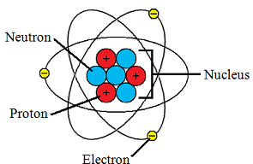  5. What element is pictured below? ________________  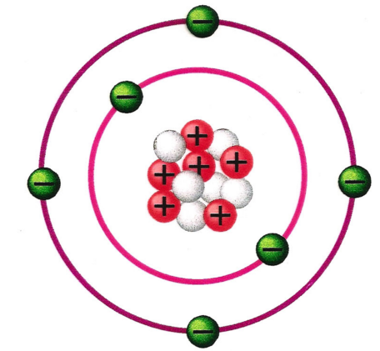  5. What element is pictured below? ________________  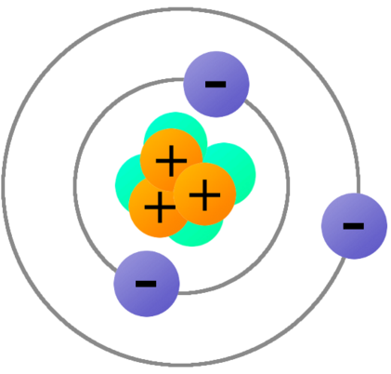  7. What element is pictured below? ________________  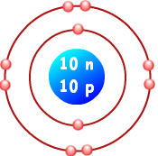
7 | If you looked at an atom that had 13 protons, 14 neutrons, and 13 electrons, what would it be? __________________  If you looked at an atom that had 18 protons, 18 neutrons, and 17 electrons, what would it be? __________________  If you looked at an atom that had 9 protons, 8 neutrons, and 8 electrons, what would it be? __________________  What determines an element’s identity? _________________________
Learning Target #4: Invest in Chemical Property

8 | Watch the video and answer the questions.  1. How many electrons can go in the 1st energy level? _____  2. How many electrons can go in the 2nd energy level? _____  3. How many electrons can go in the 3rd energy level? _____
9 | Watch the video and answer the questions.  1. Groups on the Periodic Table go __________________________  2. All the atoms in group 1 have _____ valence electron.  3. All the atoms in group 2 have _____ valence electron.  4. All the atoms in group 13 have _____ valence electron.  5. All the atoms in group 14 have _____ valence electron.  6. All the atoms in group 15 have _____ valence electron.  7. All the atoms in group 16 have _____ valence electron.  8. All the atoms in group 17 have _____ valence electron.  9. All the atoms in group 18 have _____ valence electron.  10. All of the elements in group 18 have ______ valence electrons, except for ________, which has _______.
10 | Click through the Prezi to answer the questions.  1. What is a valence electron?  2. Valence electrons are important because they determine:
Learning Target #5: Now you try!

11 | Practice building atoms using this simulator. Use it to complete the following tasks and answer the questions.  - Build an atom using 4 protons, 5 neutrons, and 4 electrons. What element is it?  - The mass of the atom you built is 9. What two subatomic particles add up to make the mass?  - Click reset at the bottom right. Build a random atom. Which subatomic particle changes the element’s identity when added to the atom?  - Build an atom using 5 protons, 6 neutrons, and 5 electrons. What element is it?  - How could you tell what element it is if only a model was present?
Learning Target #6: Atomic fun!

12 | Play around with atoms.  1. How many protons did your atom of Helium have? ________  2. Where were the protons located? _______  3. How many neutrons did your atom of Helium have? _______  4. Where were the neutrons located? ______  5. How many electrons did your atom of Helium have? _______  6. Where were the electrons located? _______
13 | Head over to Quizlet to see how you’re doing so far.  Study the set titled Atomic Structure.  Study the cards until you are comfortable with the material, and then click on “Test.”  Take the test and write your score here:
14 | Test your learning on this atomic quiz.  Write your score here:
15 | If you have any questions for your teacher, write them below:

