Integumentary System
Complete the activities in this order. | As you do the activities answer these questions.  Type your answers in a different color.
Watch and Listen  https://www.youtube.com/watch?v=OxPlCkTKhzY | - What percentage of your weight is your skin?  - What system is skin in?  - What is the thinnest measurement of skin?  - What is the thickest measurement of skin?  - Which of the five senses do Merkel Cells help with?  - How is the skin our first line of defense against bacteria?  - What is the epidermis made of?  - How often are they replaced?  - How does your skin help regulate body temperature?  - About how many hair follicles do humans have?
Read  https://www.ducksters.com/science/skin.php | - What does the integumentary system consist of?  - What are the 3 main functions of the skin?  - .  - .  - .  - How does the skin protect us?  - How does the skin help to regulate temperature?  - What is the epidermis?  - What is the dermis?  - What is the hypodermis?
Identify  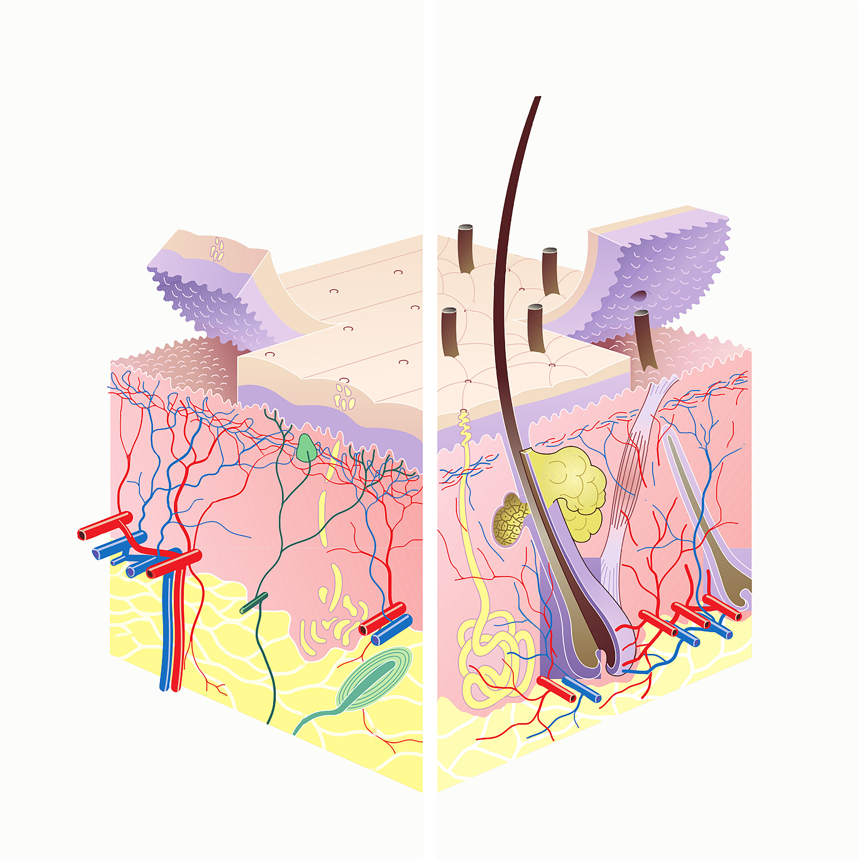  1.  2.  3.  4.  5.  6. | Identify the following parts in the image to the left: epidermis, dermis, hypodermis, blood vessels, hair follicle, and sweat gland.
Question?

Do you have any questions or misunderstandings about the integumentary system?
EXPLAIN
QUESTION ANSWER
How do the circulatory system (blood vessels), nervous system (nerves), and skin work together in the dermis?
How to pimples happen? Click the link below to find out. Then type your answer to the right.
https://www.youtube.com/watch?v=SPQt5v5Xsg8
Extend
If you finish early use the link below to find out more about the integumentary. Type 5 things you learn on the right. https://www.youtube.com/watch?v=nPk0Bb6pqIg

