Civil Rights Significance Write

Why is the event described in the article taught in schools today? What are the lasting lessons that we can learn from studying this event? Support your response with evidence from the text.

The American civil rights movement was a mass protest movement against racial segregation and discrimination in the southern United States that came to national prominence during the mid-1950s. This movement had its roots in the centuries-long efforts of African slaves and their descendants to resist racial oppression and abolish the institution of slavery. Although American slaves were emancipated as a result of the Civil War and were then granted basic civil rights through the passage of the 14th and 15th amendments to the U.S. Constitution, struggles to secure federal protection of these rights continued during the next century.
Through nonviolent protest, the civil rights movement of the 1950s and '60s broke the pattern of public facilities' being segregated by "race" in the South and achieved the most important breakthrough in equal rights legislation for African-Americans since the Reconstruction period (1865–77). Although the passage in 1964 and 1965 of major civil rights legislation was victorious for the movement, by then militant black activists had begun to see their struggle as a freedom or liberation movement not just seeking civil rights reforms, but instead confronting the enduring economic, political and cultural consequences of past racial oppression.

Abolitionism to Jim Crow
American history has been marked by persistent and determined efforts to expand the scope and inclusiveness of civil rights. Although equal rights for all were affirmed in the founding documents of the United States, many of the new country's inhabitants were denied essential rights. African slaves and indentured servants did not have the inalienable right to "life, liberty and the pursuit of happiness" that British colonists asserted to justify their Declaration of Independence.
Instead, the Constitution protected slavery by allowing the importation of slaves until 1808 and providing for the return of slaves who had escaped to other states.
Jim Crow laws were an official effort to keep African-Americans separate from whites in the southern United States for many years. The laws were in place from the late 1870s until the civil rights movement began in the 1950s.

Du Bois to Brown
During the early decades of the 20th century, movements to resist such racial and gender discrimination gained strength in many countries. While a Pan-African movement emerged in response to European imperialism, African-Americans developed various strategies to challenge racial discrimination in the United States. Educator Booker T. Washington emphasized economic development without openly challenging the Jim Crow system, Harvard University-educated scholar W.E.B. Du Bois became a leading advocate for civil rights and Pan-African unity among African and African descendants elsewhere in the world. In 1909, Du Bois and other African-American leaders joined with white proponents of racial equality to form the National Association for the Advancement of Colored People (NAACP), which became the country's most enduring civil rights organization. Under the leadership of Du Bois, James Weldon Johnson, Walter White, Thurgood Marshall, and others, the NAACP publicized racial injustices and initiated lawsuits to secure equal treatment for African-Americans in education, employment, housing and public accommodations.
The NAACP faced competition from various groups offering alternative strategies for racial advancement. In 1941 labor leader A. Philip Randolph's threat to stage a march on Washington, D.C., prodded President Franklin D. Roosevelt to issue an executive order against employment discrimination in the wartime defense industries. The interracial Congress of Racial Equality (CORE) also undertook small-scale civil disobedience to combat segregation in Northern cities. In the aftermath of World War II, African-American civil rights efforts were hampered by ideological splits. Du Bois and prominent African-American entertainer Paul Robeson were among the leftist leaders advocating mass civil rights protests while opposing the Cold War foreign and domestic policies of President Harry S. Truman, but Truman prevailed in the 1948 presidential election with critical backing from NAACP leaders and most African-Americans able to vote. Marshall and other NAACP leaders gained additional black support when the Supreme Court ruled public school segregation unconstitutional in 1954 in the NAACP-sponsored case of Brown v. Board of Education of Topeka. Yet, even as the NAACP consolidated its national dominance in the civil rights field, local black activists acted on their own to protest racial segregation and discrimination. For example, in 1951 a student walkout at a Virginia high school led by Barbara Johns, age 16, was one of the local efforts that culminated in the Brown decision. When the Supreme Court did not set a time limit for states to desegregate their school systems and instead merely called for desegregation "with all deliberate speed," the stage was set for years of conflicts over public school desegregation and other discriminatory practices.

Montgomery bus boycott to the Voting Rights Act
The Montgomery bus boycott, a mass protest against the bus system of Montgomery, Alabama, by civil rights activists and their supporters led to a 1956 Supreme Court decision declaring that Montgomery's segregation laws on buses were unconstitutional. The 381-day bus boycott also brought the Rev. Martin Luther King Jr., into the spotlight as one of the most important leaders of the American civil rights movement.
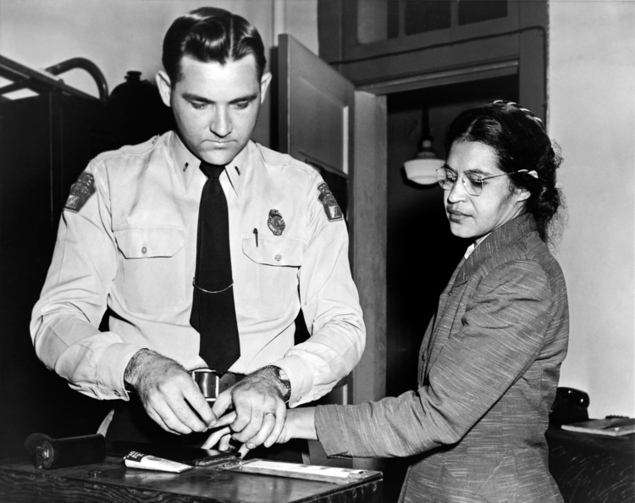Rosa Parks being fingerprinted by police after her refusal to move to the back of a bus to accommodate a white passenger touched off the bus boycott, Montgomery, Alabama, 1956.
Four years later, four black college students in Greensboro, North Carolina, sparked a new phase of the Southern civil rights movement on February 1, 1960, when they staged a sit-in at a drugstore lunch counter reserved for whites. In the wake of the Greensboro sit-in, thousands of students in at least 60 communities, mostly in the upper, urbanized South, joined the sit-in campaign during the winter and spring of 1960. Despite efforts by the NAACP, Southern Christian Leadership Conference (SCLC), and CORE to impose some control over the sit-in movement, the student protesters formed their own group, the Student Nonviolent Coordinating Committee (SNCC), to coordinate the new movement. SNCC gradually acquired a staff of full-time organizers, many of whom were former student protesters, and launched a number of local projects designed to achieve desegregation and voting rights. Although SNCC's nonviolent tactics were influenced by King, SNCC organizers typically stressed the need to develop self-reliant local leaders to sustain grass-roots movements. The Freedom Rides of 1961 signaled the beginning of a period when civil rights protest activity grew in scale and intensity. CORE sponsored the first group of bus riders who sought to desegregate Southern bus terminals. After attacks by white mobs in Alabama turned back the initial protesters, student activists from Nashville and other centers of sit-in activities continued the rides into Jackson, Mississippi, where they were promptly arrested for disobeying racial segregation rules. Despite U.S. Attorney General Robert F. Kennedy's plea for a "cooling-off" period, the Freedom Rides demonstrated that militant but nonviolent young activists could confront Southern segregation at its strongest points and pressure the federal government to intervene to protect the constitutional rights of African-Americans. The Freedom Rides encouraged similar protests elsewhere against segregated transportation facilities and stimulated local campaigns in many Southern communities that had been untouched by the student sit-ins.
Similar mass protests in dozens of other cities made white Americans more aware of the antiquated Jim Crow system, though black militancy also prompted a white "backlash." Those mass protests culminated on August 28, 1963, in the March on Washington for Jobs and Freedom, which attracted over 200,000 participants. King used his concluding "I Have a Dream" speech at the march as an opportunity to link black civil rights aspirations with traditional American political values. He insisted that the Declaration of Independence and the Constitution comprised "a promissory note" guaranteeing all Americans "the unalienable rights of life, liberty and the pursuit of happiness."
Mass protests in the Alabama cities of Selma and Montgomery led President Lyndon B. Johnson to introduce legislation that became the Voting Rights Act of 1965.

The Voting Rights Act
The Voting Rights Act of August 6, 1965, aimed to overcome legal barriers at the state and local levels that prevented African-Americans from exercising their right to vote under the 15th Amendment (1870) to the Constitution of the United States. The act significantly widened the franchise and is considered among the most far-reaching pieces of civil rights legislation in U.S. history. In the 1950s and early 1960s the U.S. Congress enacted laws to protect the right of African-Americans to vote, but such legislation was only partially successful. In 1964, the Civil Rights Act was passed and the 24th Amendment, abolishing poll taxes for voting for federal offices, was ratified, and the following year President Lyndon B. Johnson called for the implementation of comprehensive federal legislation to protect voting rights. The resulting act, the Voting Rights Act, suspended literacy tests, provided for federal approval of proposed changes to voting laws or procedures ("preclearance") in jurisdictions that had previously used tests to determine voter eligibility (these areas were covered under Sections 4 and 5 of the legislation), and directed the attorney general of the United States to challenge the use of poll taxes for state and local elections. An expansion of the law in the 1970s also protected voting rights for non-English-speaking U.S. citizens.

Into the 21st century
As was the case for formerly colonized people in countries that achieved independence during the period after World War II, the acquisition of citizenship rights by African-Americans brought fewer gains for those who were poor than for those who possessed educational and class advantages. American civil rights legislation of the 1960s became the basis for affirmative action — programs that increased opportunities for many black students and workers as well as for women, disabled people, and other victims of discrimination. Increased participation in the American electoral system lessened black reliance on extralegal tactics. Some former civil rights activists, such as John Lewis, Andrew Young and Jesse Jackson, launched careers in electoral politics. Black elected officials, including mayors, began to exert greater influence than either black power proponents or advocates of nonviolent civil rights protests.
In 1969, believing that by speaking with a single voice they would have greater influence, 13 African-American members of the U.S. House of Representatives formed the Congressional Black Caucus "to promote the public welfare through legislation designed to meet the needs of millions of neglected citizens." By the early 21st century that caucus numbered more than 40 members and could count among its achievements legislative initiatives involving minority business development, expansion of educational opportunities, and opposition to South Africa's former apartheid system. However, civil rights issues continued to stimulate protests, particularly when previous gains appeared to be threatened.
Overall, the 20th-century struggle for civil rights produced an enduring transformation of the legal status of African-Americans and other victims of discrimination. It also increased the responsibility of the government to enforce civil rights laws and the provisions of the Civil War-era constitutional amendments. Civil rights reforms did not, however, alter other determinants of the subordinate status of African-Americans who remain in racially segregated communities where housing, public schools, and health care services are inferior. Like freedom struggles in Africa, the African-American freedom struggle eliminated slavery and legally mandated forms of racial oppression, but the descendants of former slaves and colonized people generally remained in subordinate positions within the global capitalist economic order.
Still, in the early 21st century the ascent to the U.S. presidency of an African-American, Barack Obama, seemed to reflect a transformation of American society with ramifications for the civil rights movement (see United States presidential election of 2008). Jesse Jackson in his own landmark campaigns for the Democratic presidential nomination in 1984 and 1988 had reached beyond the effort to mobilize African-American voters and attempted to fashion a "Rainbow Coalition" of "red, yellow, brown, black and white" Americans. Obama — whose father was a black Kenyan and whose mother was a white American — presented a life story grounded in a search for a satisfactory racial identity. Ultimately, Obama's approach to the world and, arguably, his appeal to many voters were transracial, grounded in a sophisticated understanding of the complex nature of racial identity that was no longer merely dichotomous — no longer simply a matter of black or white. Given the deeply rooted racial conflicts of the American past, however, it is unlikely that Obama's election signaled the start of a post-racial era without divisive racial issues and controversies.

