Changes in Ecosystems Digital Interactive Activity
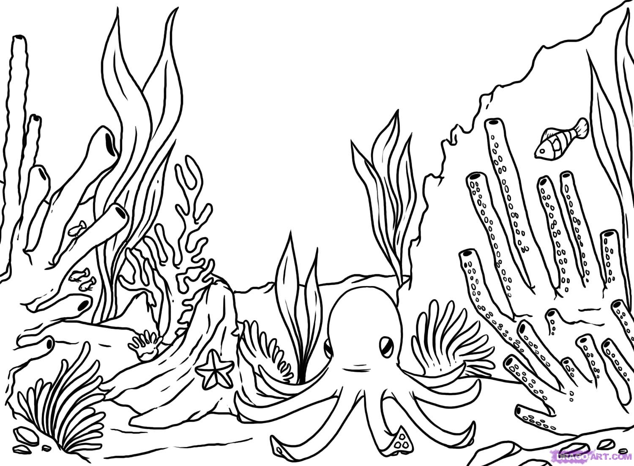

Directions: Click on each activity link in order, and then respond to each question within that activity.

Activity | Response
Explore | Explore this website about ecosystems. Write five pieces of information that you found most interesting and explain why. Complete the data table.  Information Explanation  1.  2.  3.  4.  5.  What is an ecosystem? Type here:
Examine | Examine these photos of ecosystems. Type your answers following each question.  - What was one ecosystem you were already familiar with?  - What are some of the living and non-living things you observed in one of the ecosystems?  - Looking at slide 6 at the Kelp Forest, what do you think would happen to the ecosystem if the sea otter population suddenly increased?
Watch | Watch this video on sea otters. Summarize the video below in 2-3 sentences:  What would happen to kelp forest if you took the sea otters out of their ecosystem? Answer this question here:
Learn | Learn about “Changes in Ecosystems”! Then, type your answers following each question:  - What can destroy an ecosystem?  - How can you protect an ecosystem?  - TRUE or FALSE: Ecosystems can be changed by human factors and non-human factors such as natural disasters.  - Why must some plants and animals adapt if there were something such as a drought happening?  Write a paragraph summarizing how one can protect the ecosystem. Type Paragraph Here:
Compare  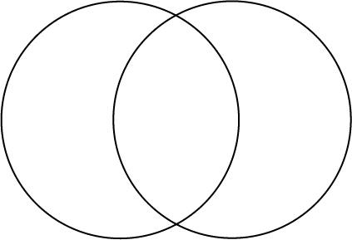 | Compare and contrast the Tropical Rain Forest to the Coral Reef. Then, complete the table.  Features of the Coral Reef Features of the Tropical Rain Forest  Type your answers following each question:  What provides the energy for both of these ecosystems?  What could cause a tropical rainforest ecosystem to change?  What could cause a coral reef ecosystem to change?
Read | Read this article about how Hurricane Irma destroyed turtle nests in Florida.  Write a paragraph summarizing the cause and effects of this problem. Type Paragraph Here:  What is the difference between an endangered species and an extinct species? Type here
Analyze | Analyze this picture of a fire in an ecosystem. Then type your answers following each question.  - How would the animal have to adapt in order to survive?  - What damage to the ecosystem could the fire cause?
Kristen Keegan, IUSD

