We will review the alphabet in Spanish
I will complete complete words by reading the alfabet

Assignment scheduled for the week of April 14th due on the 17th

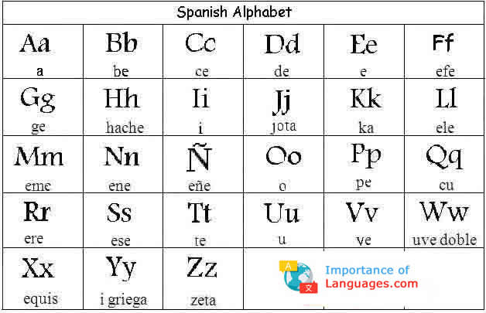

First, read the pronunciation of the alphabet in Spanish above.

Second, read each spelled out alphabet letter below and write the Spanish word in the blank.
Only write the answer.

1. efe - ele - o - erre __________________________
2. e- ele - e - efe - a - ene - te - e __________________________
3. e - ese - ce - u - e - ele - a __________________________
4. e - ese - te- u - de - i - a - ene - te - e __________________________
5. ce - hache - o - ce - o - ele - a - te - e __________________________
6. a - eme - o - erre __________________________
7. hache-o-ele-a __________________________
8. a-de-i-o-ese __________________________
9. eme-u-ce-hache-o __________________________
10. ge-u-ese-te-o _________________________

