In the early 1800’s, the economic and political differences between the North and South began to grow. These regions, also known as sections, developed very different economies and ideas about what the strength of the US government.  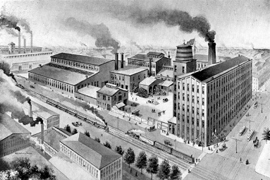  The northern states developed an industrial economic system starting after the War of 1812. To protect their domestic manufacturing businesses, northern states wanted to place high tariffs on British goods. This would encourage US citizens to buy US goods rather than foreign goods. Many northern states also began to support a growing movement known as abolitionism. Abolitionists wanted to abolish (get rid of) the institution of slavery. Abolitionists such as, William Lloyd Garrison, Frederick Douglass, Harriet Beecher Stowe, and Harriet Tubman, fought very hard to end slavery.  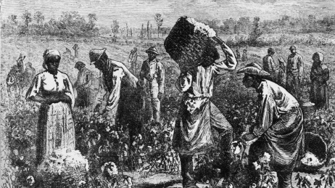  The southern states relied heavily on cash crops, like tobacco, rice, indigo, and cotton, for their economic growth. These crops were grown on large plantations that demanded intense labor. Southern plantation owners enslaved thousands of Africans, and African Americans, and forced them to work without any freedoms. The southern states wanted the government to support the institution of slavery and allow them to expand into the west by adding more slave states and slave territories. These southern states also opposed the tariffs that the northern states wanted to pass because it hurt their economy. | 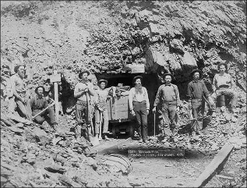  People living in the west focused mostly on expanding their states and territories by increasing the population and growing the infrastructure. Railroads, canals, and national roads were built to increase the population in the west. Those who lived in these territories and states mostly farmed and mined for gold for their economic growth. While some states and territories were free in the west, others were given popular sovereignty which allowed them to vote on the issue.  These sectional differences, especially between the North and South, caused immense tension to build in the United States. The government would pass several compromises to ease these tensions, but they ultimately would fail. By 1861, the country entered into a Civil War.  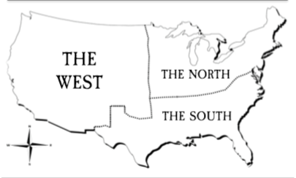  Directions: Use this information to create visual representations of the differences between the regions of the United States. The map you will use is on page two, and an example is provided on page three.
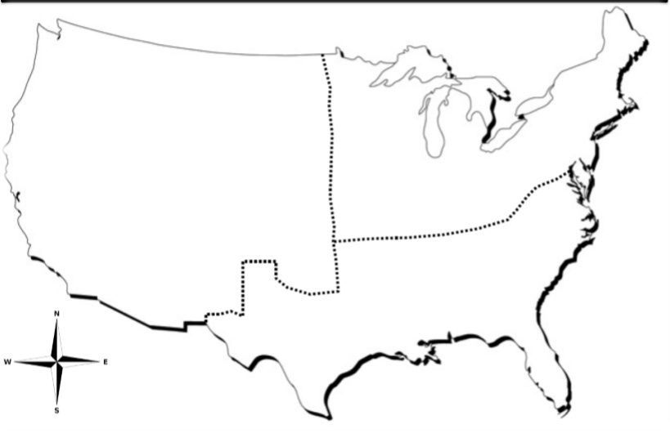

EXAMPLE
