Party Functions
Hosting Conventions
The major political parties in the U.S. host the Democratic and Republican National Conventions to select candidates and rally supporters.
LEARNING OBJECTIVES
Describe the informal aims of the national conventions

Political parties in the United States that will be fielding nominees in an upcoming U.S. presidential election are responsible for hosting presidential nominating conventions. The formal purpose of the conventions is to select the party’s candidates for president and vice president. The conventions develop a statement of party principles and goals known as a party platform. Another formal purpose of presidential nominating conventions is to adopt the rules for a given party’s activities, such as the presidential nominating process for the following election cycle.
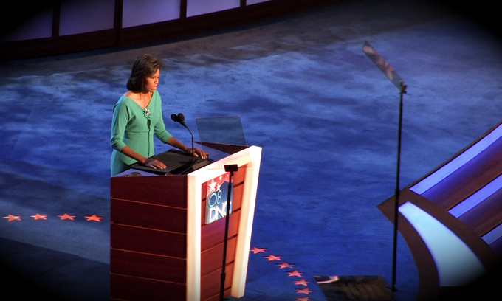
Democratic National Convention: Presidential nominating conventions, like the Democratic National Convention, host influential speakers to increase party unity.
Nominating conventions also carry significance beyond their formal purposes. Conventions are an opportunity to rally political supporters and reward the party faithful by allowing them to participate asdelegates. Due to the national media presence surrounding presidential nominating conventions, they are also excellent tools to showcase a given party’s leaders and policies to prospective voters.
The two major political parties in the U.S. host the quadrennial Democratic National Convention and Republican National Convention to determine their respective presidential and vice presidential candidates. The Democratic National Committee administers the Democratic National Convention while the Republican National Committee administers the Republican National Convention. In recent years, candidates from the Democratic and Republican parties have been known in advance of these conventions. Subsequently, the more modern focus of the Democratic and Republican National Conventions has been to unify each respective party by having delegates vote on issues that the nominee can incorporate into their presidential campaign. The conventions also generate positive publicity towards each respective party.
Some minor political parties in the U.S. also utilize conventions to select their presidential candidates. Examples of such minor parties include the Green Party, Socialist Party USA, Libertarian Party, Constitution Party, and Reform Party USA.

Selecting Candidates
Election candidates have often been determined before conventions, but are still formally declared as their party’s official candidates at the conventions.
LEARNING OBJECTIVES
Describe the roll call method of voting during a convention

Introduction
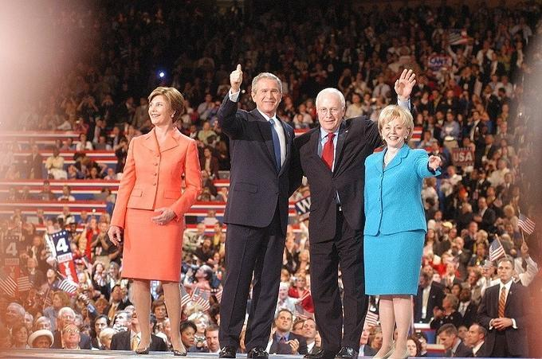
2004 Republican National Convention Presidential and Vice Presidential Candidates: George W. Bush and Dick Cheney were declared the official presidential and vice presidential candidates at the 2004 Republican National Convention.
The Democratic National Committee and Republican National Committee create the rules governing the caucuses and primaries in which the field of presidential nominees is narrowed. These nominees then proceed to the presidential nominating conventions where a candidate will officially be determined.
The presidential candidates of the two major political parties in the United States are formally confirmed during the Democratic National Convention and Republican National Convention. Each party determines its own rules for the format of the convention and how participation is to be apportioned. Generally, each U.S. state and territory is allotted a select number of voting representatives, known individually as delegates and collectively as the delegation. The size of each delegation depends upon the unique formula used by a given political party. Such formulas usually consider the population of a given state, the state’s previous presidential voting patterns, and the number of Congressional representatives or government officials in a state who are members of the party.
Voting Using the Rolling Roll Call
The voting method used during a convention is known as a rolling roll call of the states. The spokespersons of the states are called upon in alphabetical order by state name to announce their delegation count or to pass. After all states have either declared or passed, those states that passed must announce their delegate count. The decision to pass is usually made beforehand to give either the delegation of the presidential or vice presidential candidates’ home state the honor of casting the majority-making vote.
In recent years, presidential nominees have been known well in advance of the Democratic and Republican National Conventions due to changes in election laws, earlier primary elections and caucuses, and the manner in which political campaigns are run. However, the presidential nominating conventions still serve as the official method of selecting presidential candidates.
Organizing Campaigns and Elections
Political parties play key roles in organizing campaigns and elections.
LEARNING OBJECTIVES
Name other activities that fall under the auspicies of the national political committees

In addition to hosting conventions and selecting candidates to run in presidential elections, political parties play key roles in organizing campaigns and elections. The Democratic National Committee (DNC) and Republican National Committee (RNC), in particular, are the central organizations devoted to campaign and political activity in support of the Democratic and Republican Party candidates. The DNC and RNC are permanent offices maintained by the Democratic and Republican parties to govern the daily operations of each party, as well as the special election and campaign operations conducted every four years. The DNC and RNC establish connections between followers of the Democratic and Republican parties with the respective leadership of each party. Such connections play a vital role in allowing presidential candidates to maintain a base of supporters they can depend upon during elections.
The Democratic National Committee and Republican National Committee connect voters with party leadership in a variety of ways. At the start of the preliminary election season, the DNC and RNC are responsible for establishing the rules for the caucuses and primary elections. These caucuses and primaries are usually not run by the DNC and RNC but instead by the state. Aside from the process of nominating a presidential candidate, the DNC and RNC’s roles in selecting candidates to run on the Democratic and Republican Party ticket is minimal.
Later, the DNC and RNC supervise the presidential nominating conventions that officially declare the Democratic and Republican presidential candidates. Once a presidential candidate is chosen from each respective party, the Democratic and Republican National Committees provide crucial candidate support and party-building activities. Candidate support activities range from collecting polling data to running ad campaigns. Meanwhile, party-building activities often include voter registration and get-out-the-vote drives. The DNC and RNC also engage in coordinating fundraising and election strategies.
Informing the Public
Informing the public by traditional and modern mass media is a goal of the DNC and RNC, who gain supporters by remaining.
LEARNING OBJECTIVES
Describe the role the national committees play on behalf of the major political parties
Public Relations
The Democratic National Committee (DNC) and Republican National Committee (RNC) provide an important link between the Democratic and Republican leaders and the general public. The DNC and RNC vie for the attention of the public in hopes of attracting voters. using multimedia strategies that encompass both traditional as well as more modern approaches. Traditional mass media approaches include issuing press releases and coordinating staged events; more modern approaches include reaching out to prospective constituents through Facebook pages, Twitter feeds, and YouTube channels.
Both Democratic and Republican parties have developed sophisticated websites that provide extensive information about voting logistics, candidates and officeholders, and issue positions. These party websites also provide a means for direct participation in the DNC or RNC by providing information on volunteer activities and other opportunities to contribute to the Democratic and Republican Parties.
Political parties also play an active role in managing the media. In addition to hosting websites and populating social media, parties engage in spin with journalists and produce and air radio and television advertisements. It is important for parties to interact with the media in order to attract positive attention to their political candidates and remain viable in the public eye. Parties that have a strong media presence are the most effective in attracting volunteers and financial contributors.
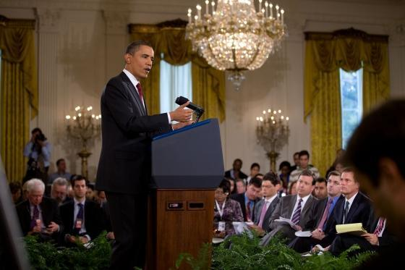
Spin: Press conferences are one way in which politicians can engage journalists in spin, or interpreting an issue or event in the favor of their political party.
The role of parties in informing the public can most clearly be seen in the relationship between the DNC and the Obama administration. After his inauguration, Obama transferred his Obama for America organization to the DNC, which renamed it Organizing for America. Under the leadership of the DNC, Organizing for America controls the BarackObama.com domain and website and works closely with the White House New Media Director.

Checking the Power of the Governing Party
The legislative branch can significantly affect the power of the governing party by employing a series of checks and balances.
LEARNING OBJECTIVES
Describe the relationship between the political parties and a system of checks and balances
Checking the Power of the Governing Party
The Democratic and Republican Parties can check the power of the governing party by holding seats in the legislative branch of the government. The legislative branch of the United States government is composed of the Senate and House of Representatives. The Senate has the power to consider presidential appointments of judges and executive department heads. It also has the ability to ratify treaties. The House of Representatives has the ability to impeach and the Senate may remove executive and judicial officers. The legislative branch can also check the governing party by starting investigations against the executive branch. The House and Senate may, additionally, override presidential vetoes and have the sole power to declare war.
If one political party holds the executive branch of government then another political party can check the power of the executive branch by holding a majority of seats in the legislative branch. Several examples exist throughout history of this scenario. One such example can be found from the Obama administration in 2010. While the Democratic Party occupied the executive branch, the Republican Party held the majority of seats in the legislative branch. This division of parties between the executive and legislative branches impairs the ability of the president to enact policies, since the legislative branch must first approve these policies. At the same time, the president can veto legislation passed by Congress. The tendency of the Democratic Party to embrace a more active government role in the lives of citizens versus the tendency of the Republican Party to favor limited government intervention in citizens’ lives, highlights the difficulties that arise when a divided government exists.

Checks and Balances
While the checks and balances system between the executive, legislative, and judicial branches prevents any one branch from becoming tyrannical, this system has also been criticized for maintaining the status quo in government rather than promoting changes. There is a strong possibility for disagreement and conflict within the legislature and between the branches.
Uniting Competing Factions Within the Party
Democratic and Republican Parties have historically taken ideologically ambiguous positions in order to attract a wide range of supporters.
LEARNING OBJECTIVES
Differentiate between the Democratic and Republican parties

The two major Democratic and Republican Parties in the United States have historically been ideologically ambiguous in order to accommodate citizens representing a broad spectrum of interests. Instead of adopting polarizing ideological views, the Democratic and Republican Parties stand for the core American values of liberty, democracy, and equal opportunity that appeal to many Americans.
However, some broad differences still exist between the Democratic and Republican Parties. The Democratic Party is most associated with a liberal attitude toward politics that emphasizes a more active government role in regulating the economy, ensuring equality, and providing a social safety net. Meanwhile, the Republican Party tends to favor a more conservative view advocating a free market economic system and limited government intervention in the lives of citizens. Some have even contended that American parties have become more ideologically distinct in the last three decades as party leaders begin to express polarized opinions on national issues.
Even with evidence of increasing polarization between political parties, they still encompass a wide range of constituents with varying viewpoints. Parties unite these disparate viewpoints by developing party platforms that outline party positions on issues and the actions leaders will take to implement them if elected. These platforms frequently adopt middle-of-the-road positions to encompass the interests of a diverse range of supporters. Most of the language used in party platforms is generic to appeal to a wide audience while other sections are narrowly written to appeal to certain factions or interest groups in the party.
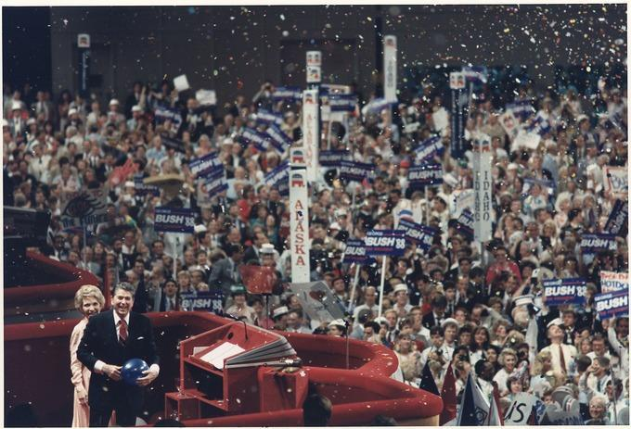
Republican National Convention: Platforms created during presidential nominating conventions unite diverse factions within a party by adopting middle-of-the-road positions on issues and addressing special interest groups in some sections.
Platforms are created during presidential nominating conventions where delegates have an opportunity to vote on salient issues. These votes present a majority view on how issues should be handled and how they can be used by the presidential candidate to unite divergent viewpoints under one popular view.
Coordinating and Promoting Party Policy
Democratic and Republican National Committees help coordinate and promote party policies but do not organize the creation of policies.
LEARNING OBJECTIVES
Summarize the role the two national committees play in the formation and promotion of policy
Coordinating and Promoting Party Policy
The Democratic National Committee (DNC) and Republican National Committee (RNC) help to coordinate and promote party policies, although they are not the central organizations that develop these policies. These organizations are responsible for developing and promoting party platforms, which express the types of views each party embraces. While the planks of platforms do not all necessarily become policies, they can lead to highly politicized debates between parties that become party policy stances. The DNC and RNC promote party policy in a variety of ways through the mass media.
The DNC and RNC coordinate party policy during the Democratic and Republican National Conventions where party platforms are adopted. These conventions allow delegates to vote on issues that can later be incorporated into a presidential candidate ‘s campaign. While relatively little of the party platform is adopted as public policy, the platforms often become politicized because they are more ideological than pragmatic. For example, the debate over abortion between the Democratic and Republican parties has resulted in policy stances that either support or ban the practice of abortion.
Meanwhile, party policy is promoted through a variety of interactions between parties and the mass media. The mass media is utilized to reach out to a nationwide audience. Traditional mass media techniques of issuing press releases and staging televised debates are used to generate attention toward a party’s policies. Parties also take advantage of more modern social media sites like Facebook, Twitter, and YouTube. The Democratic and Republican Parties, additionally, maintain sophisticated websites where they can offer comprehensive overviews of various party policies. Television and radio advertisements serve as yet another influential way in which parties can promote their policies.
Media: The DNC and RNC utilize various forms of mass media to promote their party’s policies.

